USER GUIDER
TZONE School Bus System

1、User Register
Enter the website into the system login screen. There is a login link in the lower right corner. Click on the link to enter the registration interface.
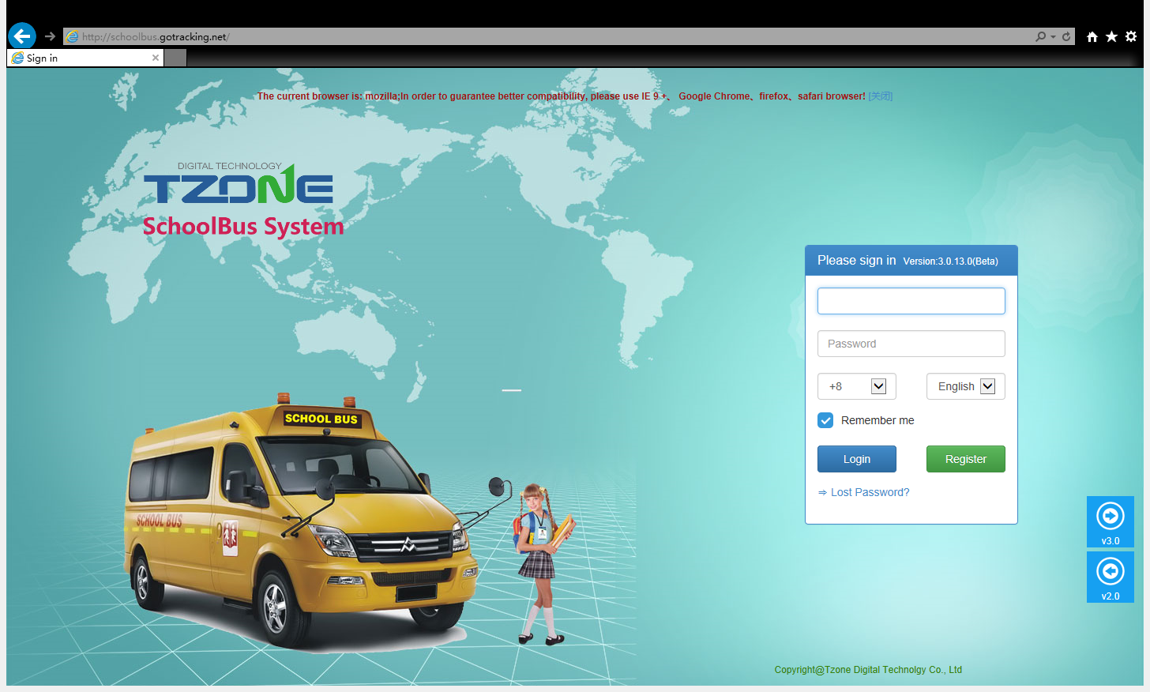

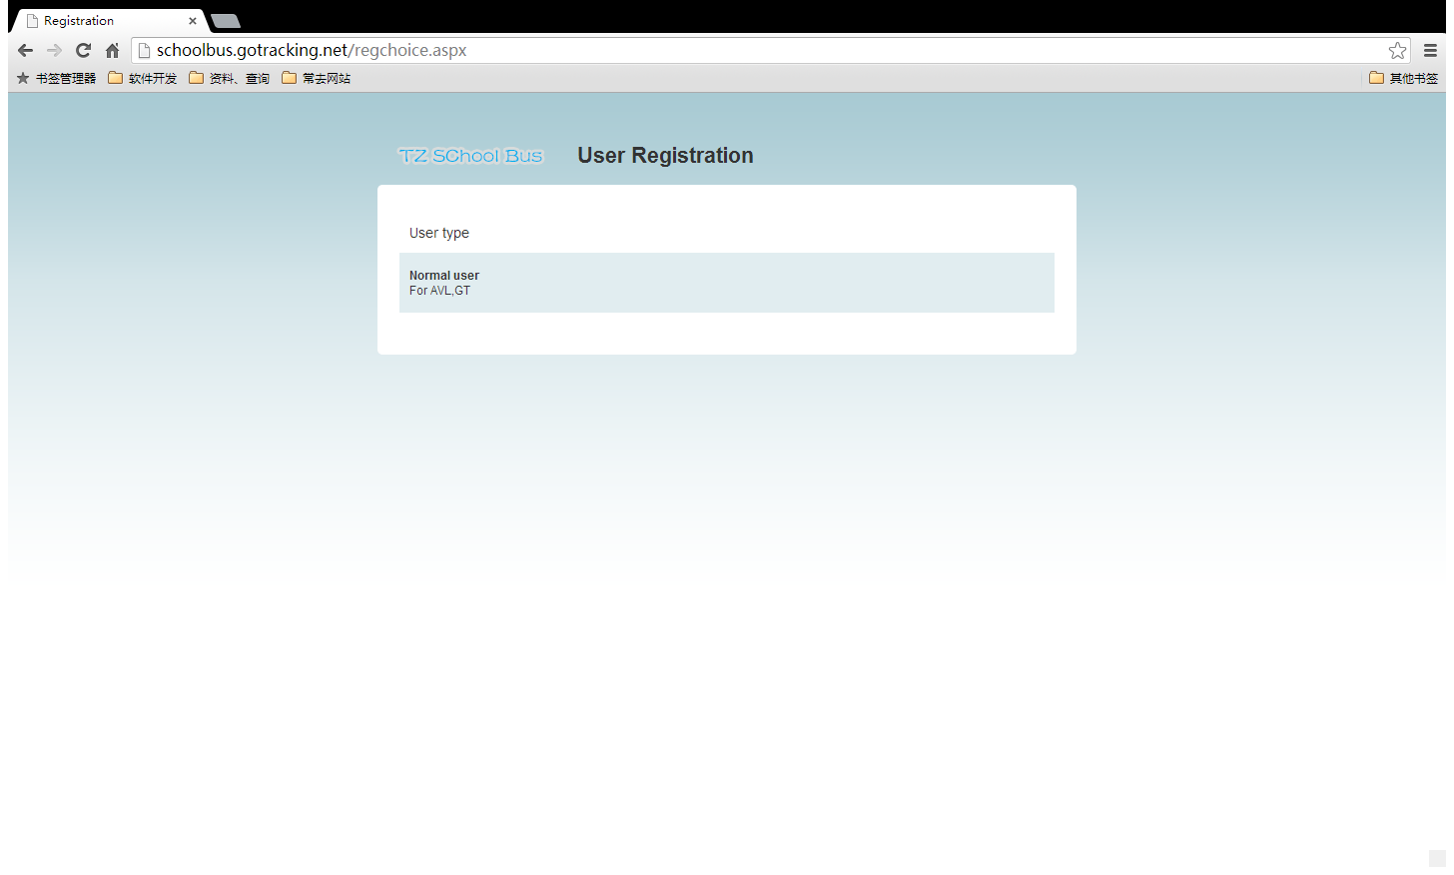

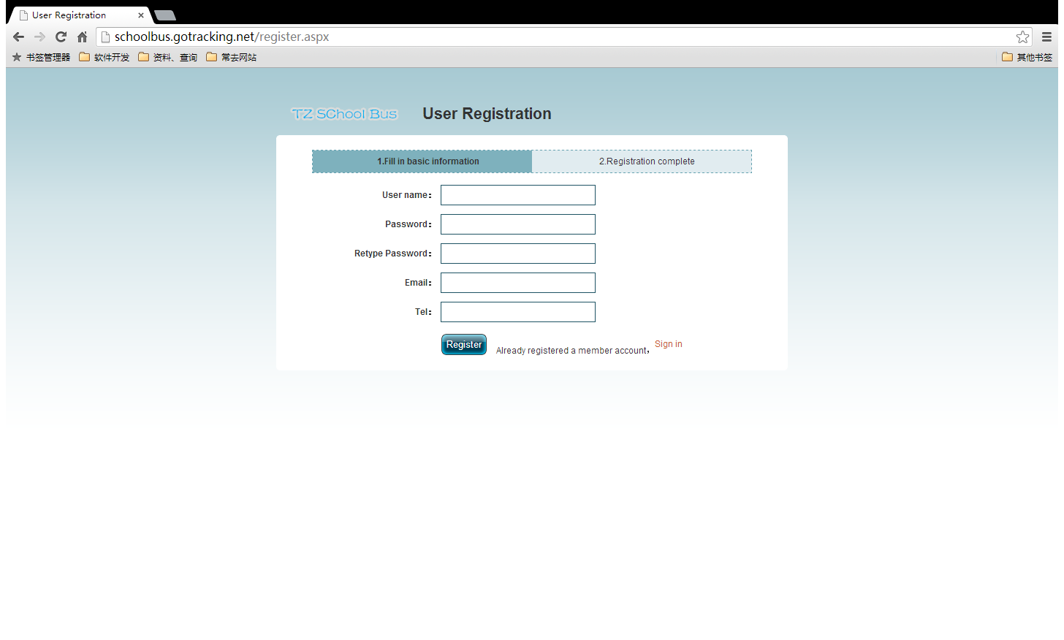

- Get Password
Click the lost password link, then input user name and the registered mailbox .if correct, the system will send an email to the corresponding mailbox. Click the password resetlink in the mailbox to reset your password.
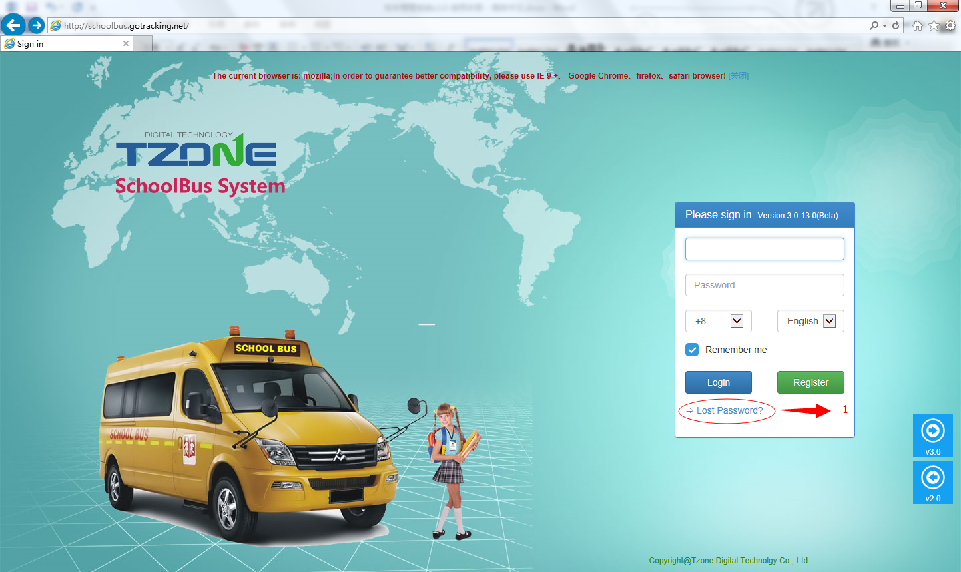

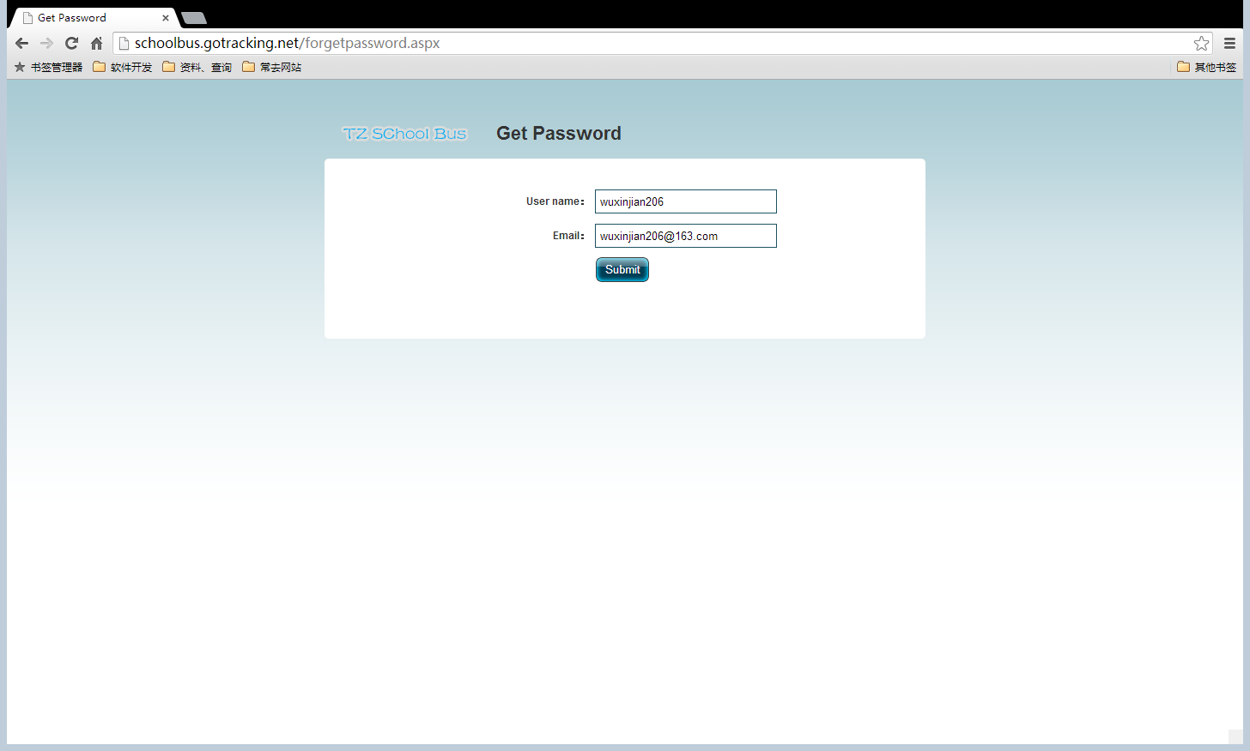

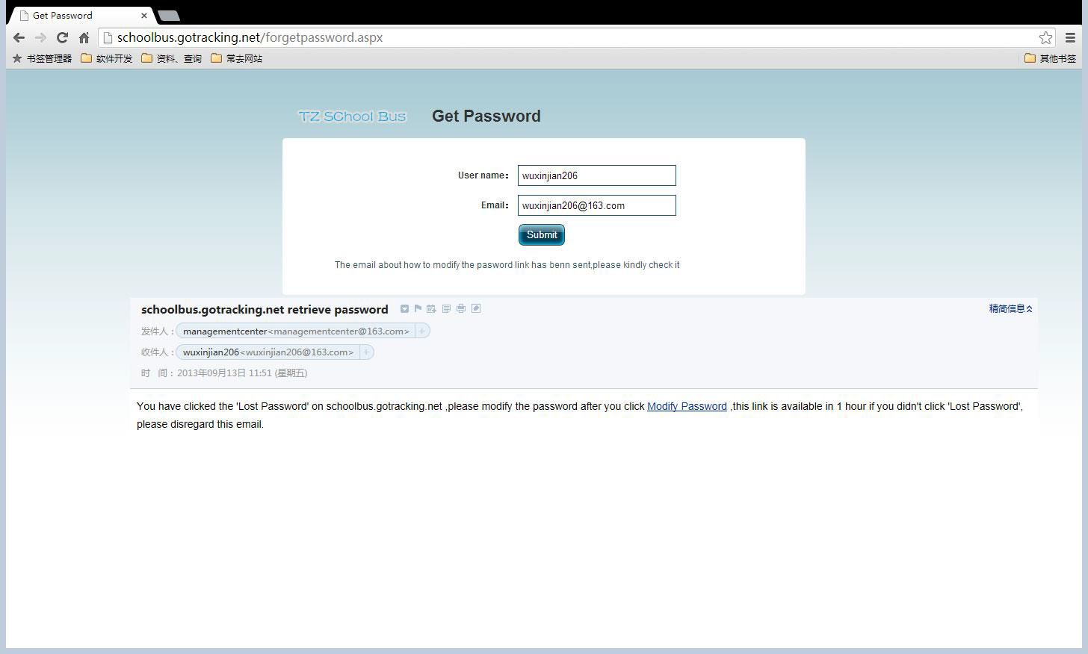

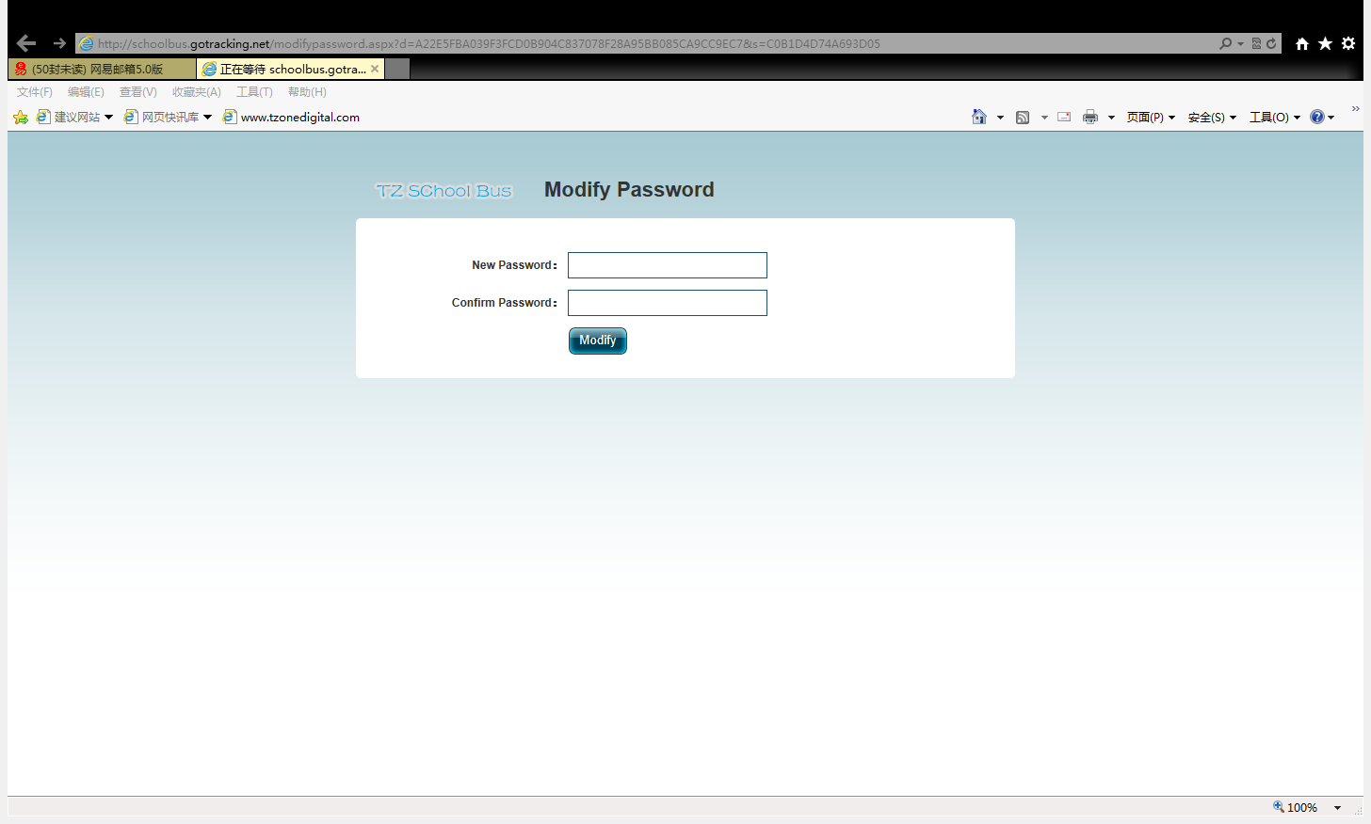

- User Login
You can select the using language and time zone in this login page.

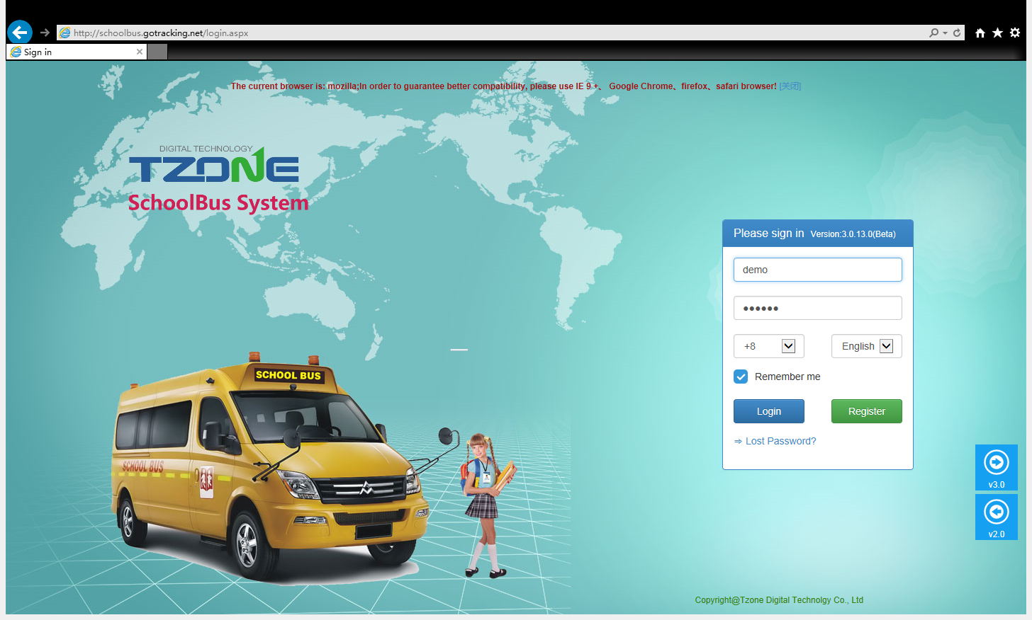

4、Home page functions
After logging system first enters home screen, home screen main display user menus, school bus real-time monitoring, the currently active products, the current alarm products; online people statistics, active product statistics, alarms product statistics, student statistics, school bus statistics, the average rate statistics .
Map icon, green represents the vehicle is running, red for alarm, gray is stopped. Front direction of the car means the current car’s driving directions.

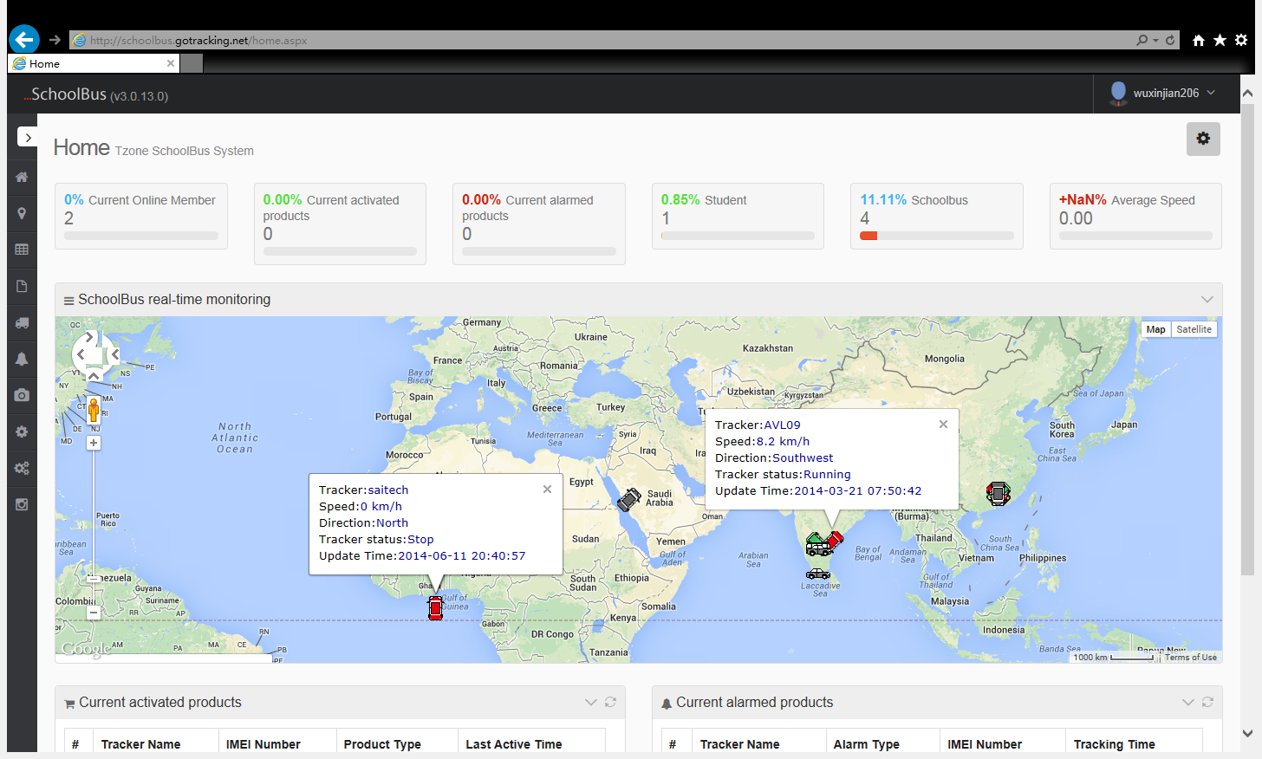
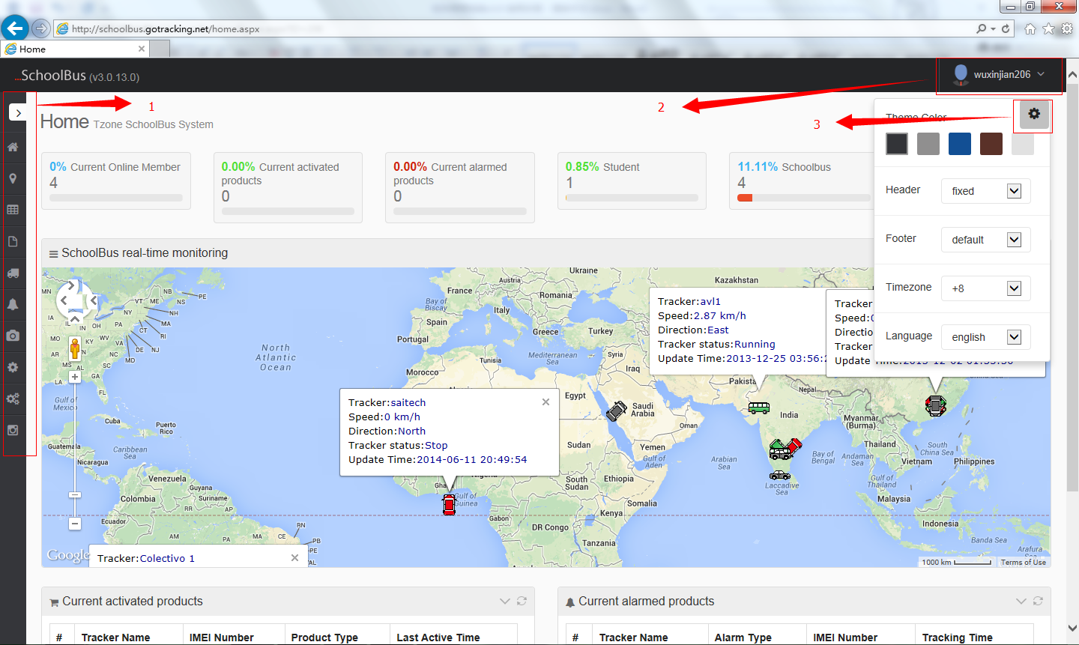

1: System Menu;
Click to go directly to the menu function
2: Current login account
Move your mouse over the account name, the account information will be displayed as well as canceled.
3: System Settings;
Users can switch their favorite theme, in line with its own language, and time zone.

5、Tracking Function
5.1 Real-time tracking

The green, red in the map represents the current state of road , green for smooth, red for congestion.

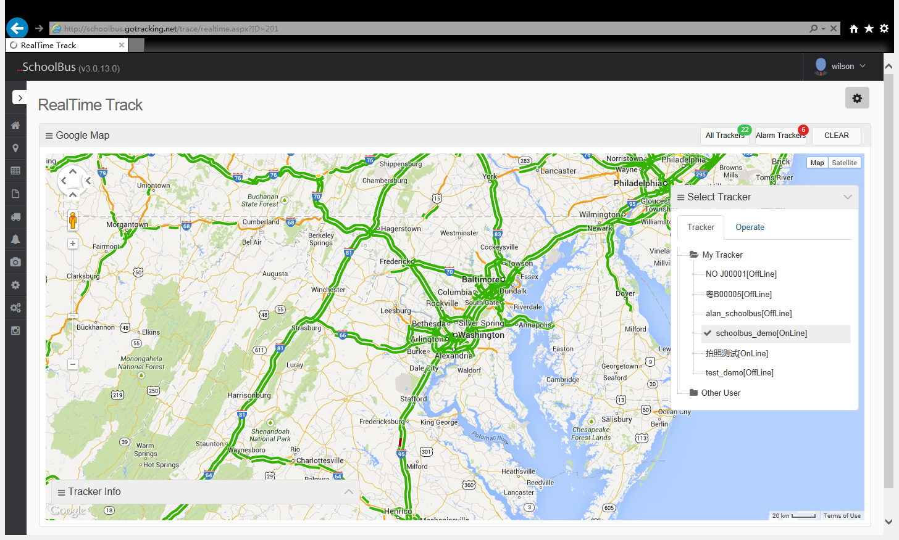
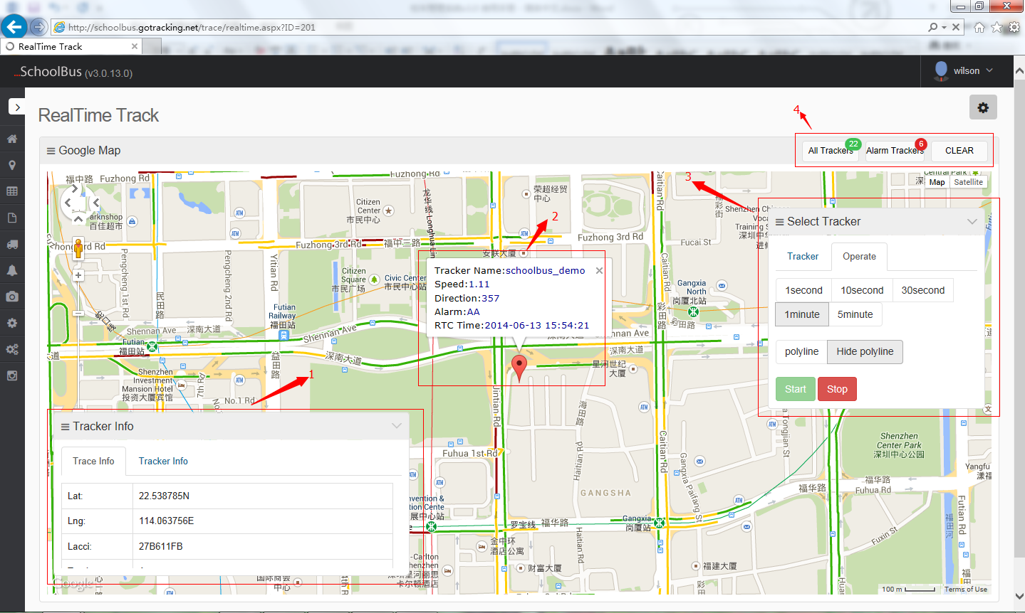

1: Information Menu
Display the current information of the tracking product (eg: the tracker’s gps data and the installation information)
2:Map display information
Display the corresponding tracker and some information on the map
3:Operation Menu
User can select the track products that they need (Expand the tree form menu to select the product), choose the track’s refreshed time interval and choose whether display ligature or not, then click the start button for real-time tracking.
4:Alarm machine, online machine
Click the chart to view the current alarm machine, online machine, clear map icon tool

Show all machines

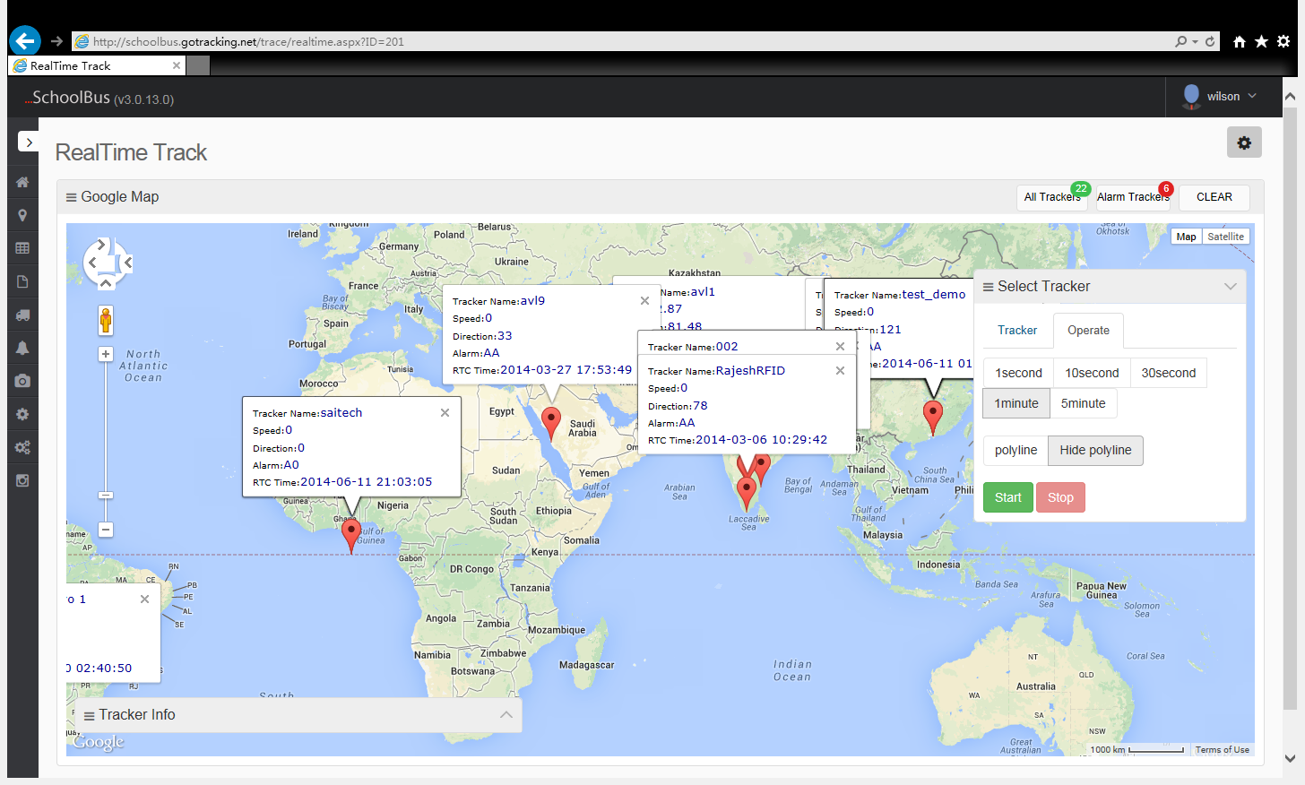

5.2 History Tracking

Click the history tracking function, then choose the tracker you want ,select the time and refresh rate, click start.

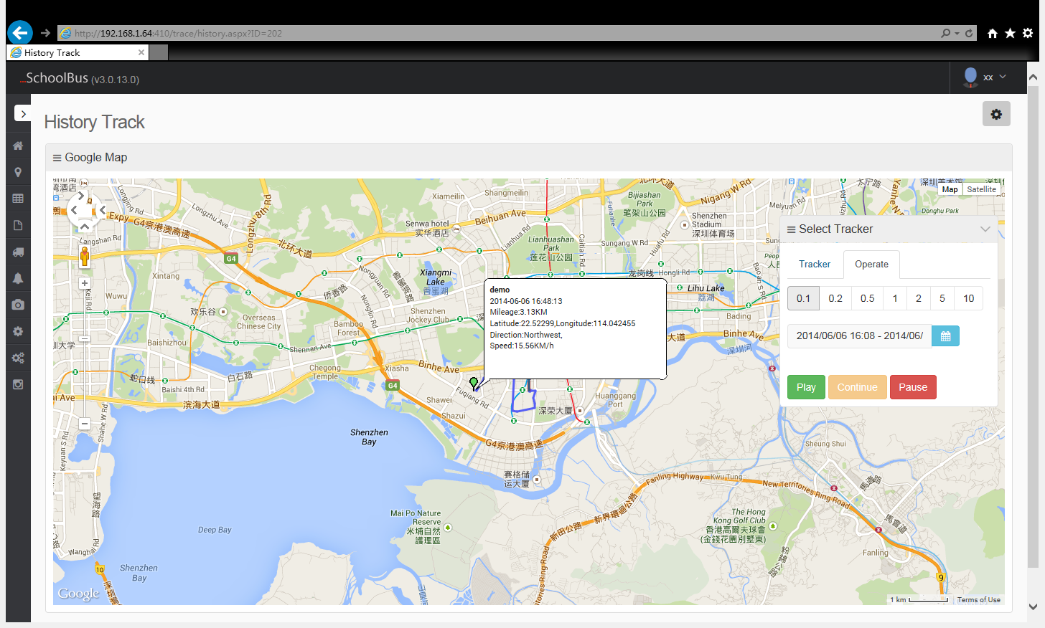

5.3 Multiple Function

Click multiple tracking function, then you can track several trackers here at the same time.

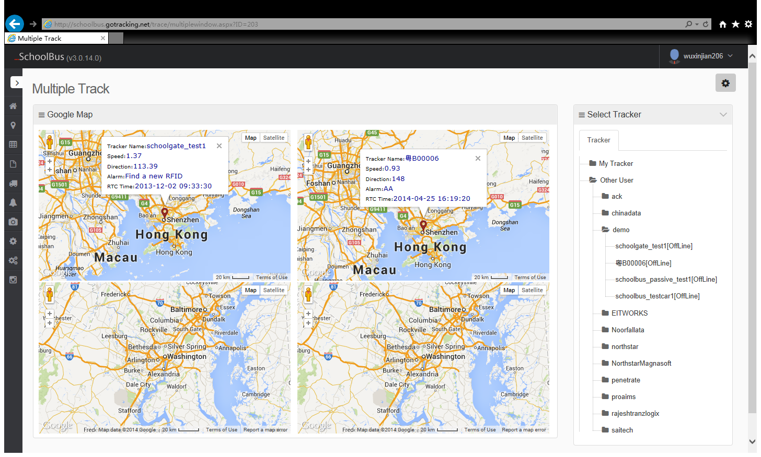

5.4 Base station Location

The based station location is same as the real-time tracking, but the latitude and longitude get here is through the base station code conversion , so it will not that accurate.
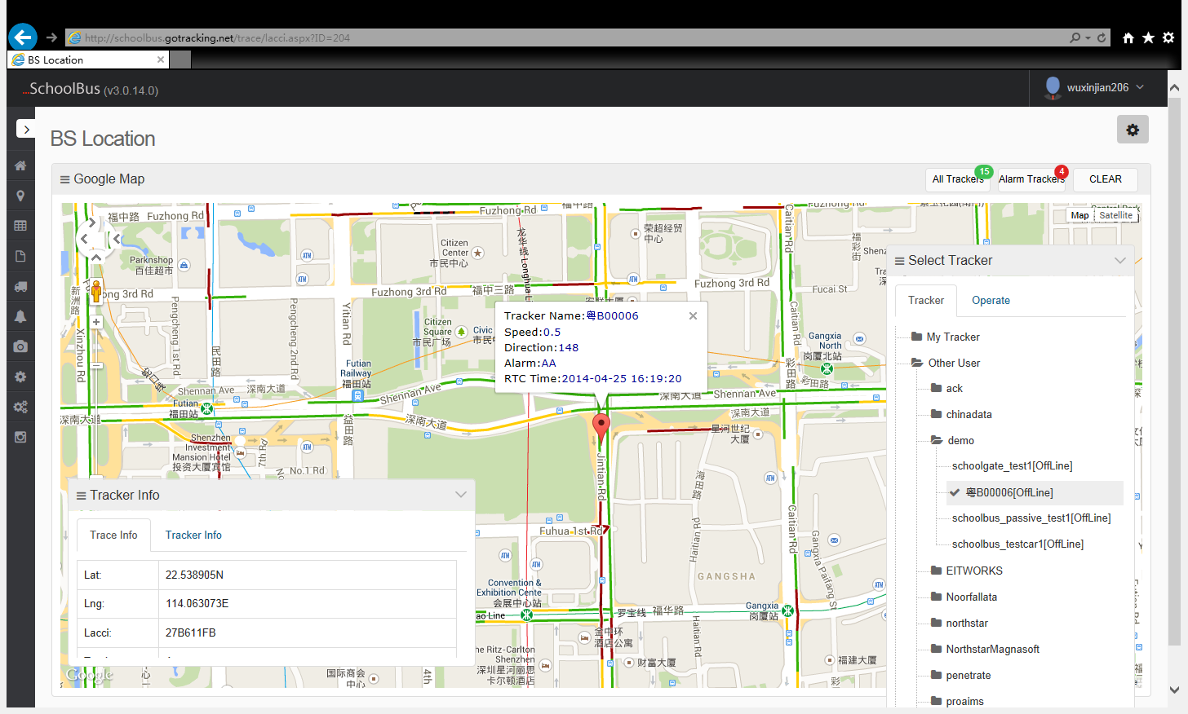

5.5 Geo-Fence

Enter the Geo-fence tracking page, select the tracker, and then you will get comparison results. One tracker can bind several fences, so the comparison results also have more than one,click the comparison results of geo-fence to view the current geo-fence on the map.

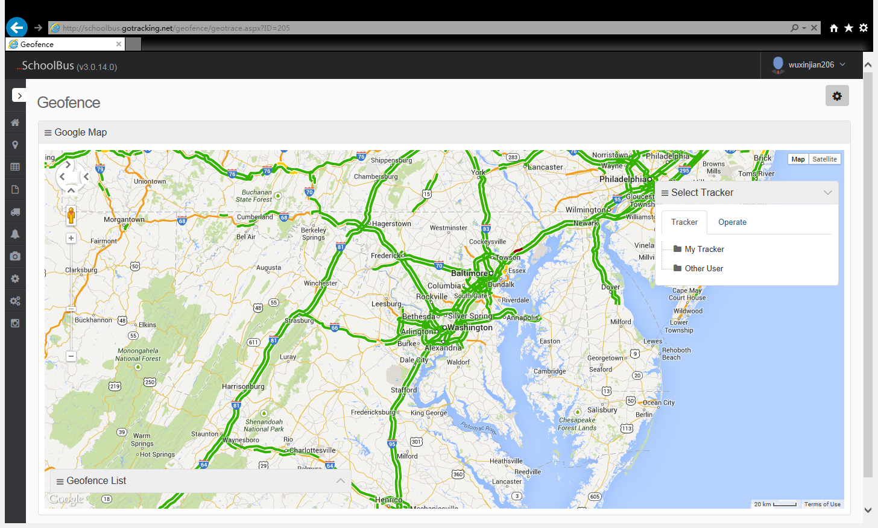

5.6 Trace bamboo figure

Trace bamboo figure is the real-time information when the school bus take the student, you can see the current school bus travel sites ,arrive time, students’ information and so on.

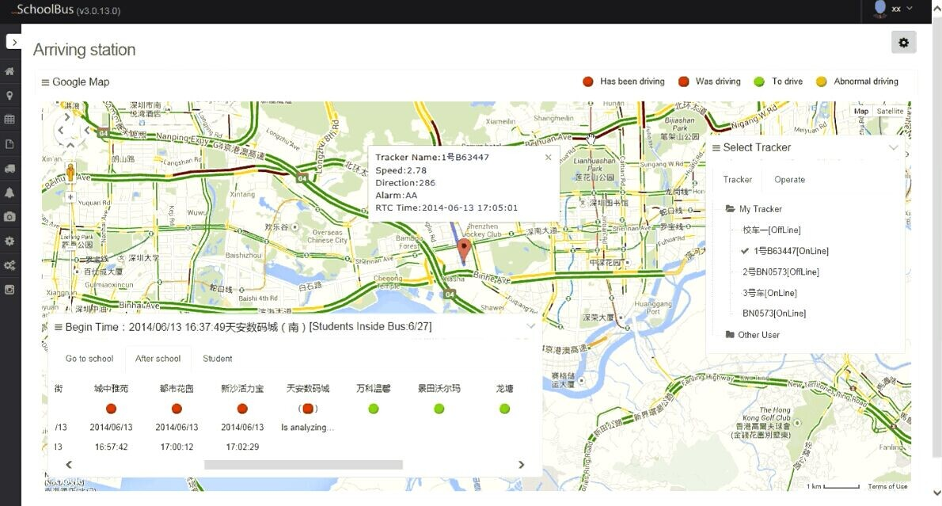

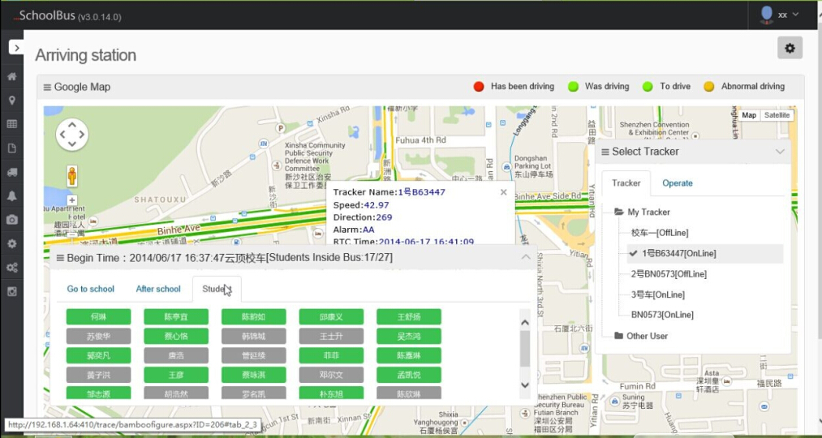

- Report Function
6.1 Speed Report

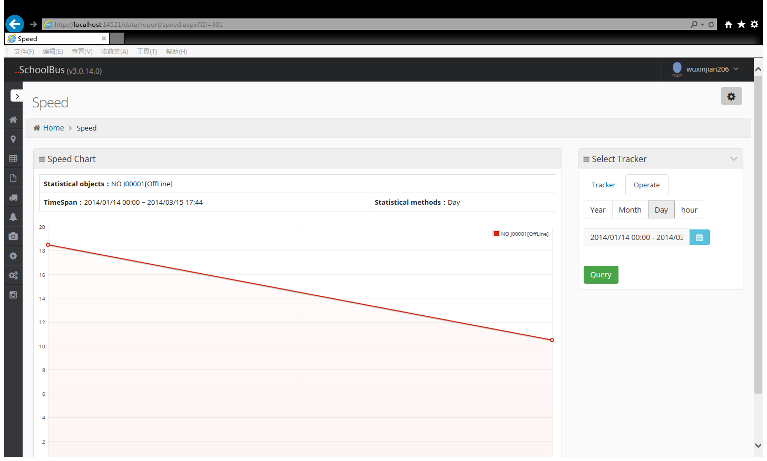

6.2 Mileage Report

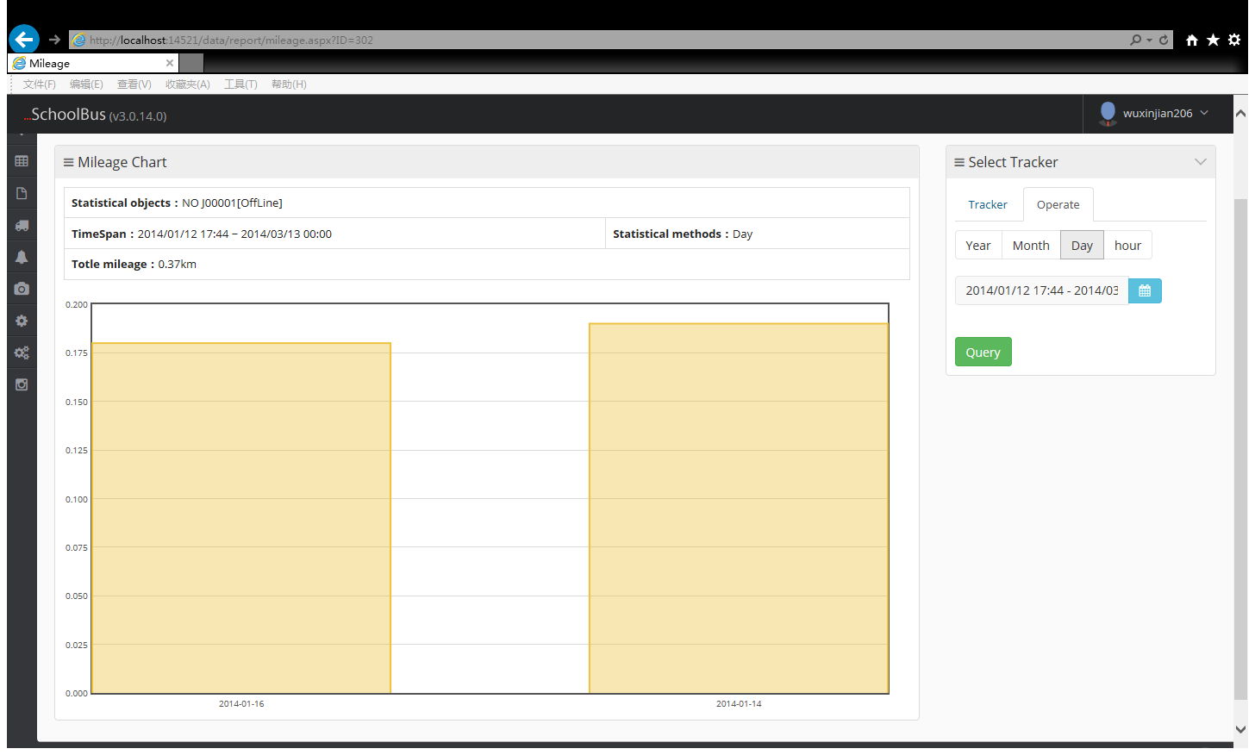

6.3 Fuel level Report

Select the tracker and choose the output items for corresponding oil sensor ,set up the oil volume (L) and track time. Click the query Note:different machines have different oil tank sizes, the page is 50L by default, if you track machine oil tank is another values please fill your corresponding machine oil tank size, Because we count the oil according to ratio.
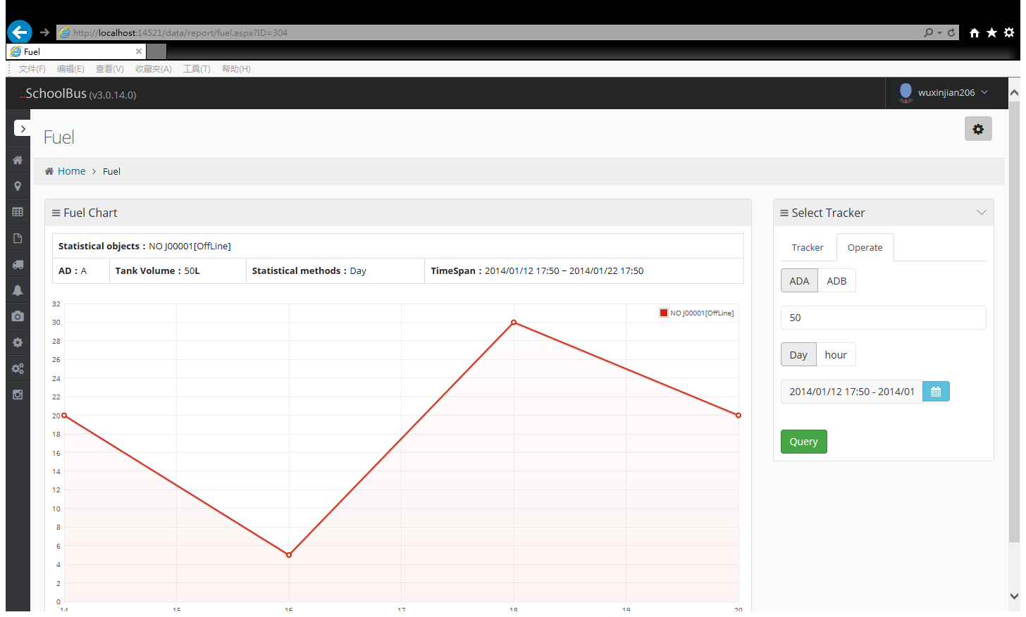

6.4 Temperature Report

Only the trackerwhich connect with the temperature sensor has this report. select the time for the tracker ,then click query to view the report.

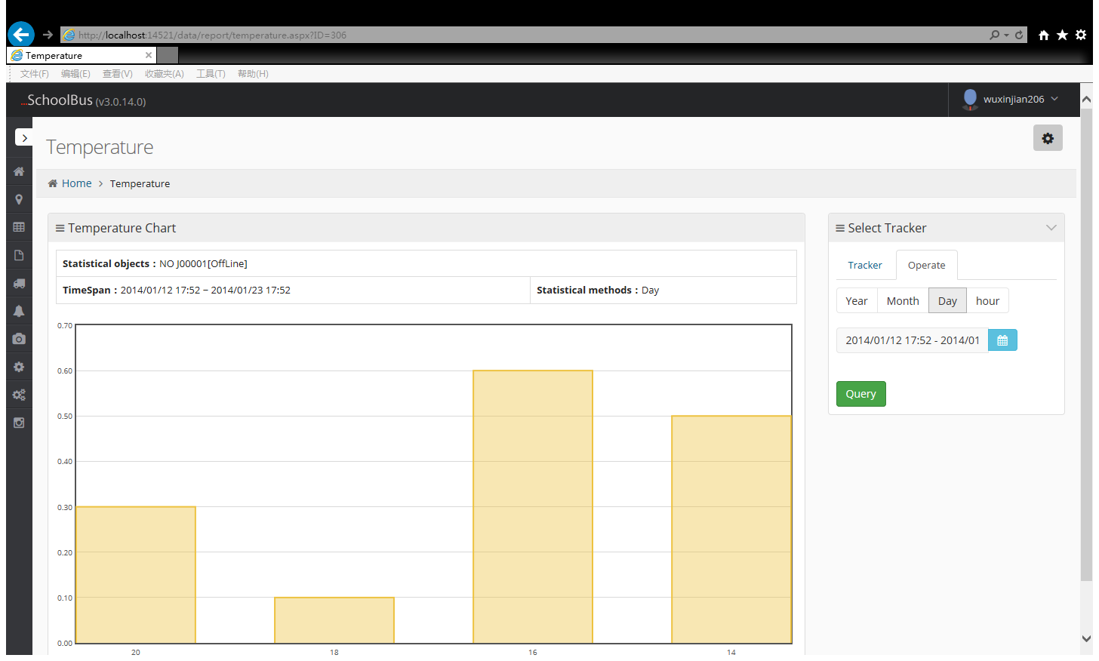

6.5 Dispatch Record

You can check how manytimes one vehicle dispatch within a period of time.

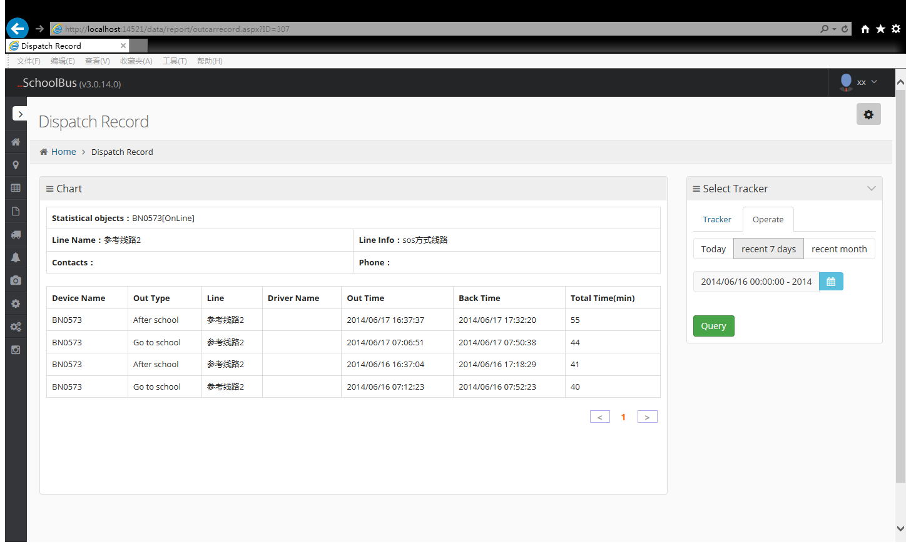

6.6 Route Record

To check the route for one car, to view the detailed record.

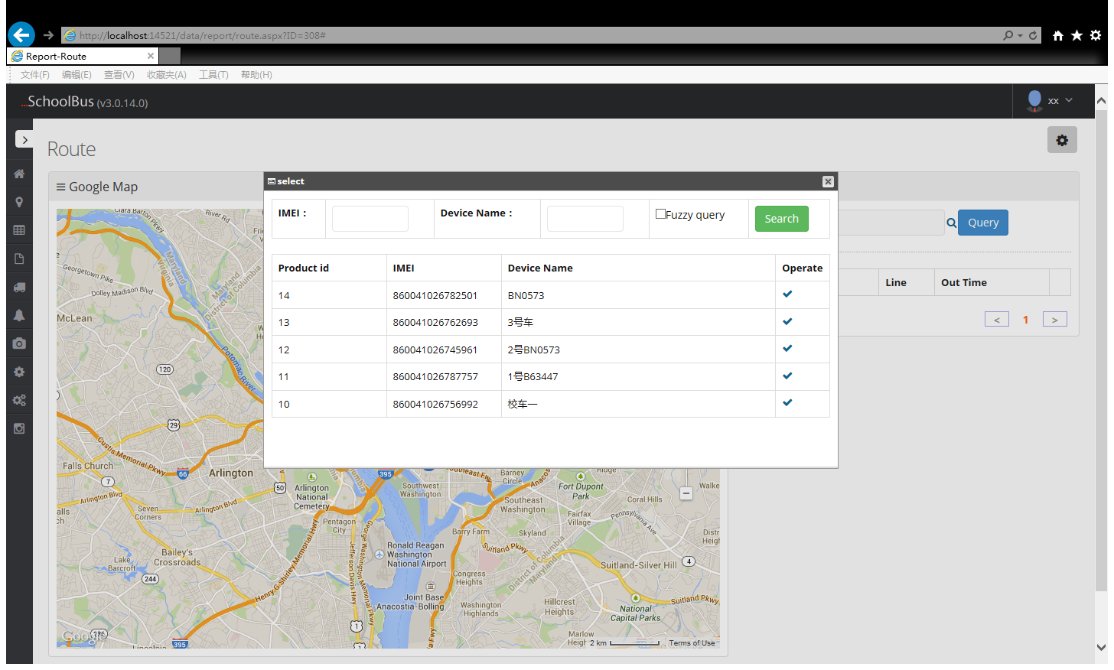

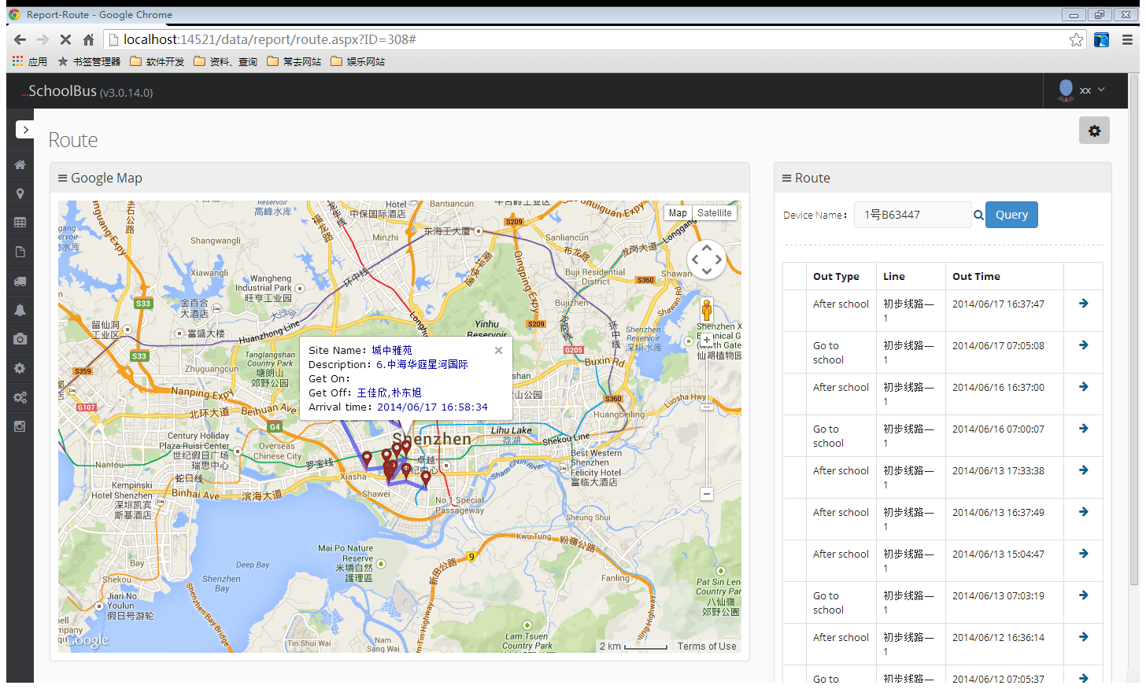

6.7 Student Travel Records

By students, student travel time query record.

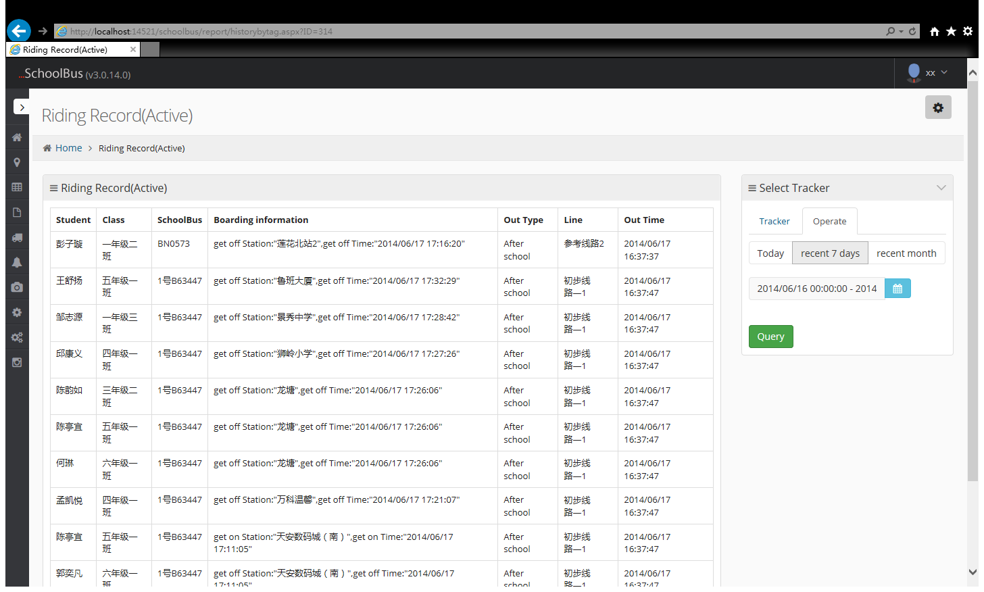

7、Basic Information

7.1 Student Information

Click the green button to add students.

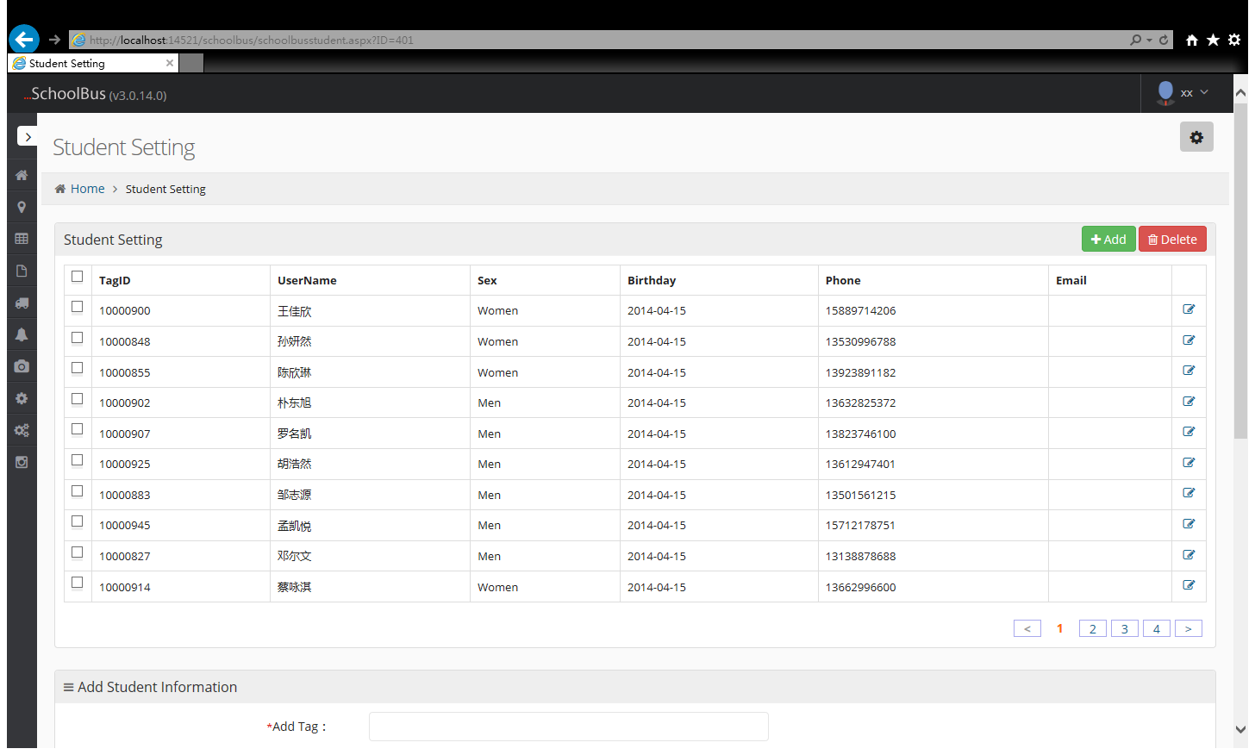

Receive Mode Select Phone or E-mail can receive student go to and from school related notice,if do not want to be harassed, and select Close.

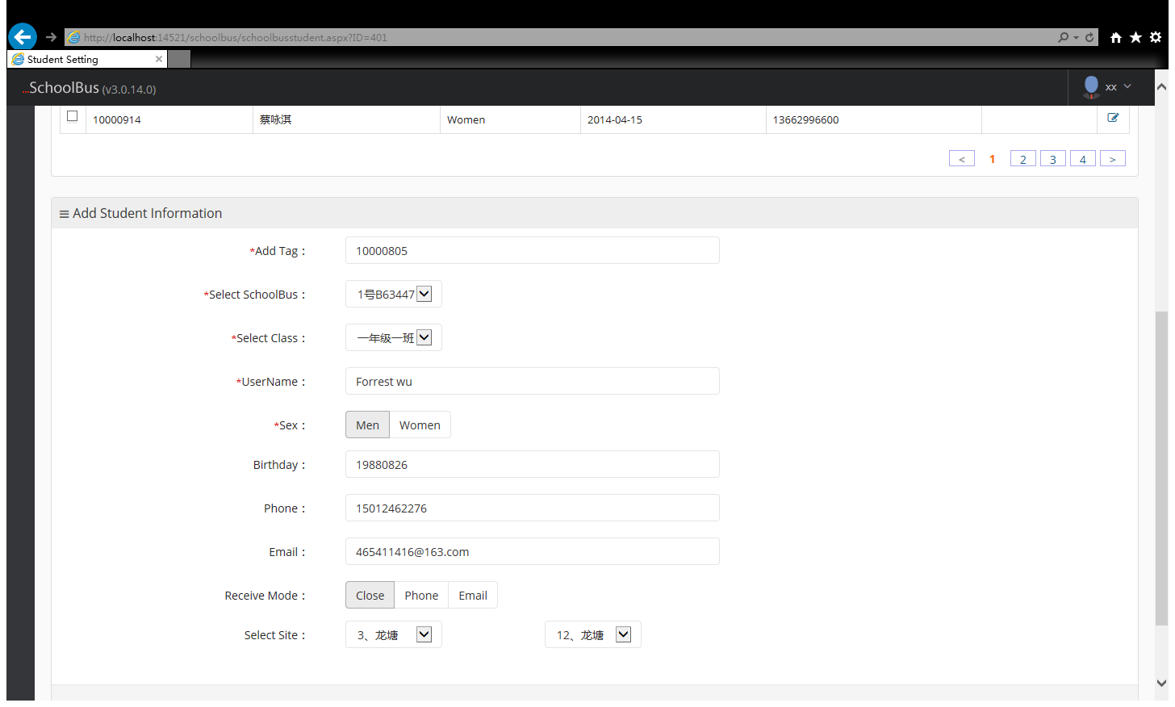

7.2 Teacher Information

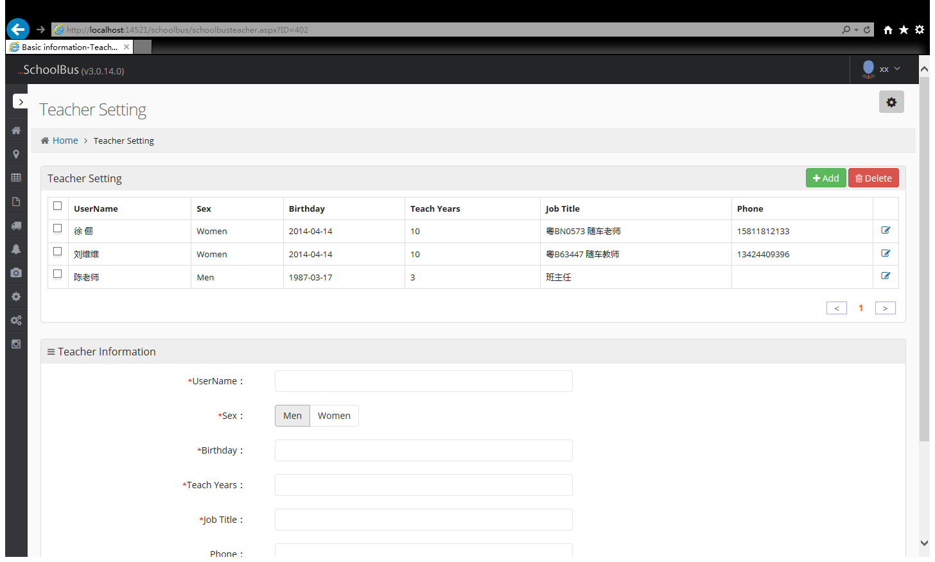

7.3 Class Information

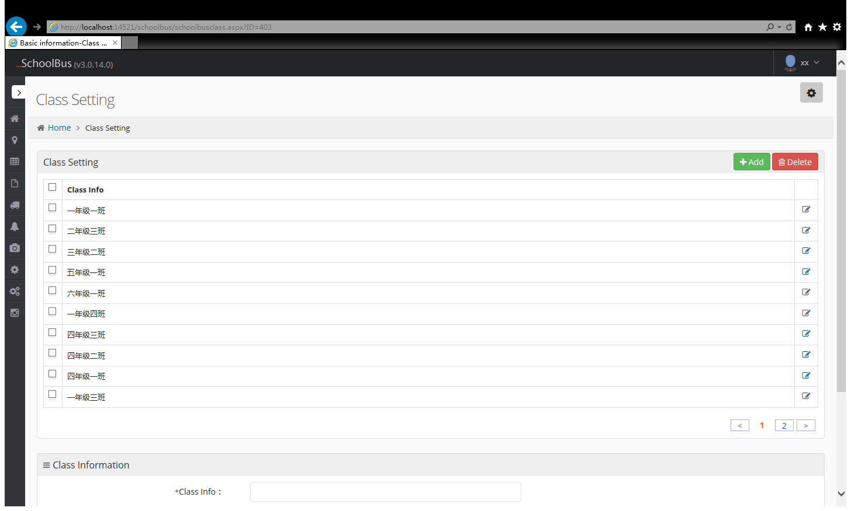

7.4 Driver Information

Each trip of going to school and after class ,driver need to swiping his card to record the route.

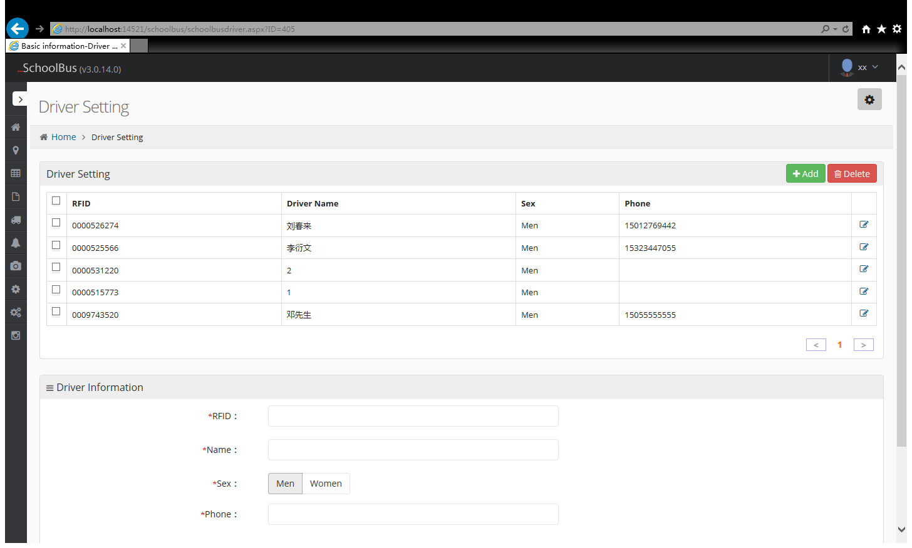

7.5 Device Setting

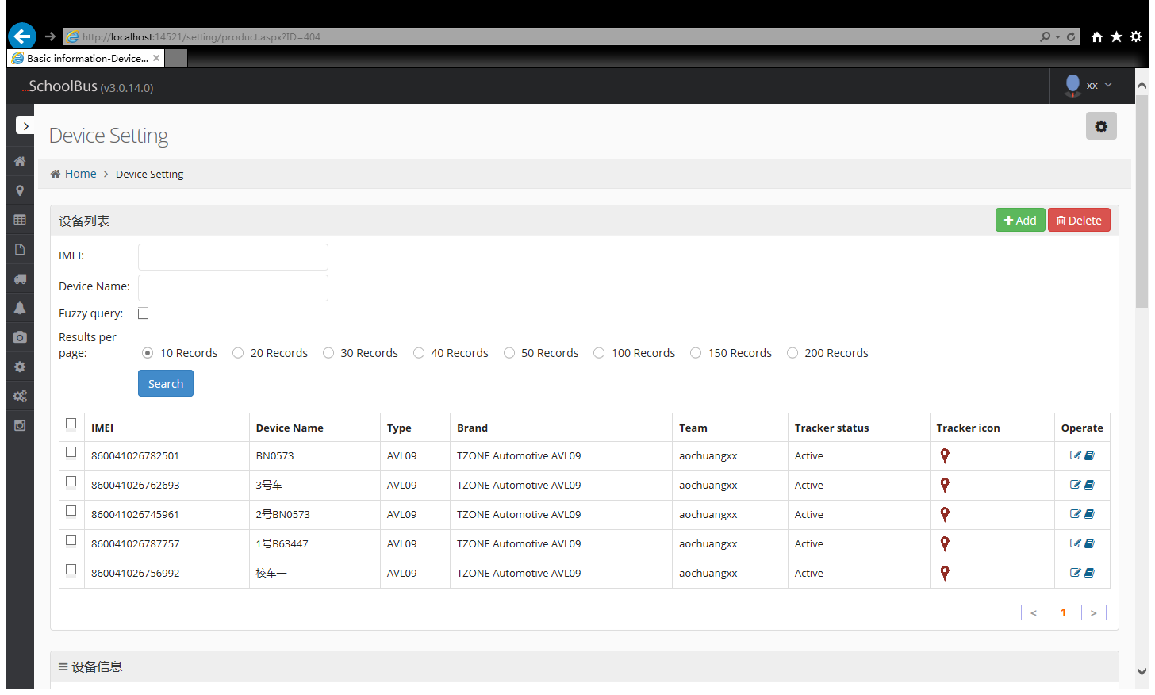

Figure 1: check in, it means that set it as a test.
Figure 2: It must be their own devices to select the corresponding models.

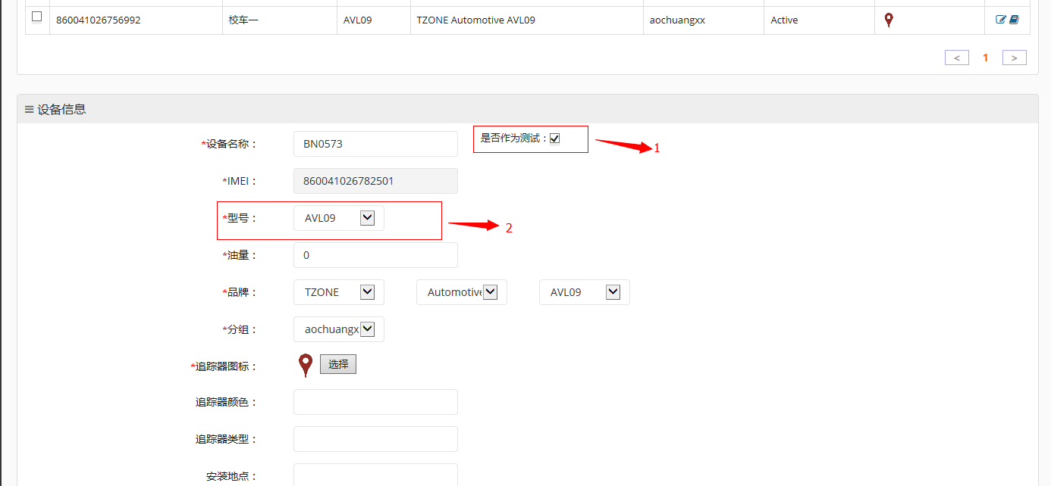

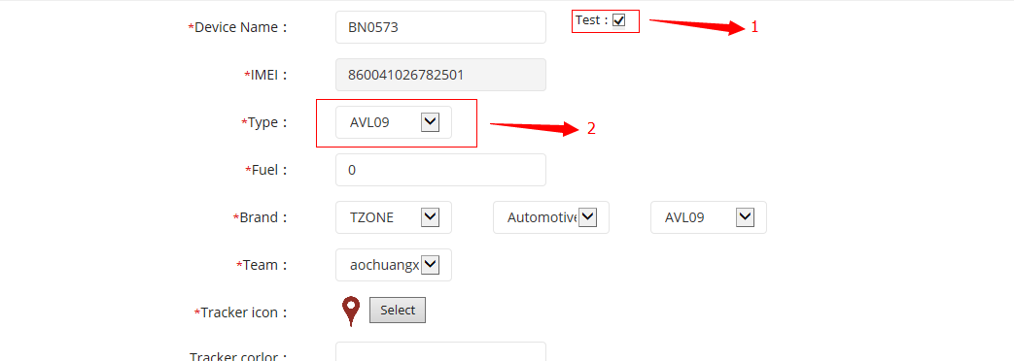

7.6 Attendance Management

Time Zone: Set the local time zone. Some features require the system to do the adjustment based on the time zone here.

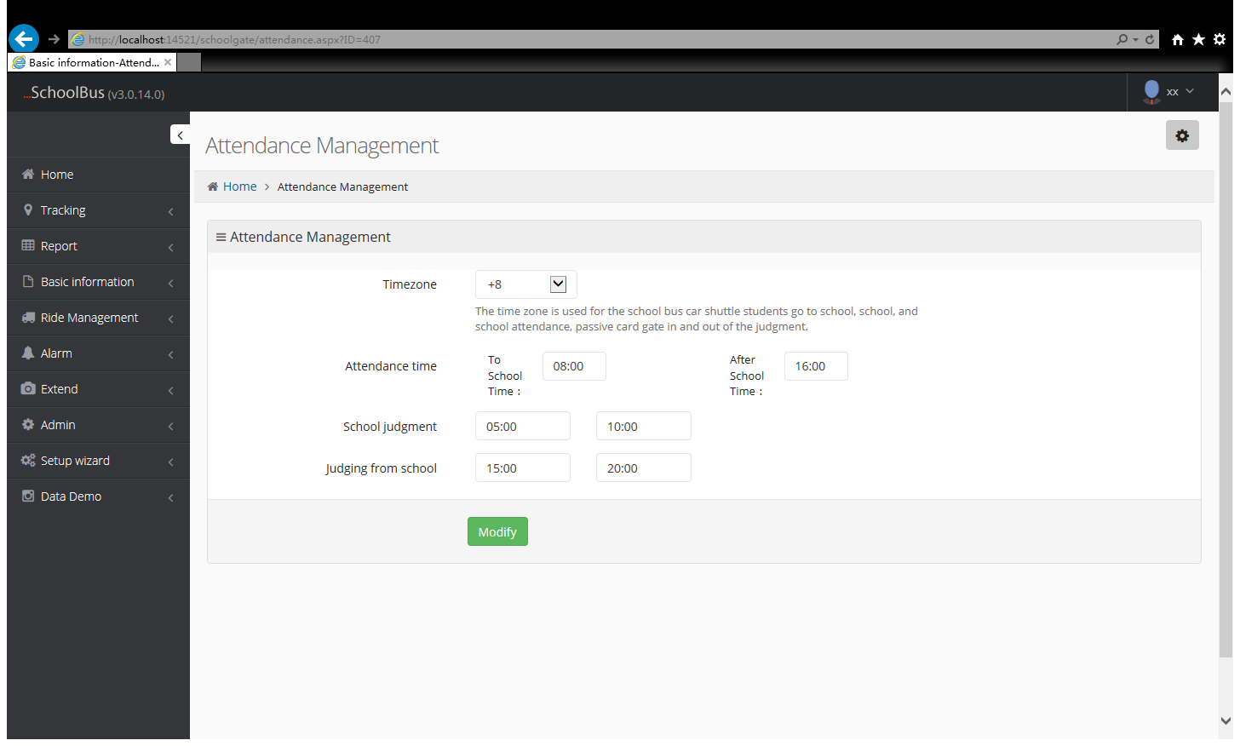

- Ride Management
8.1 Site Management

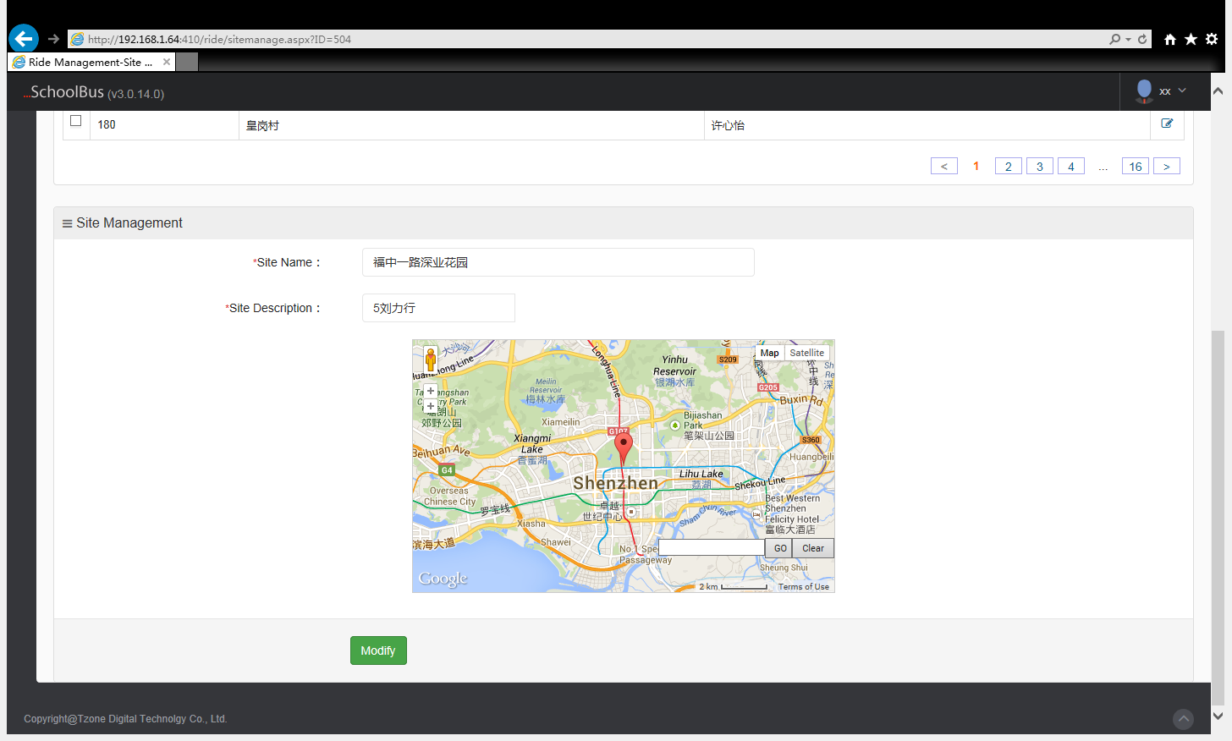

Click tracing point on the map ,can also vaguely described point by search box in the bottom right corner.

8.2 Route Management

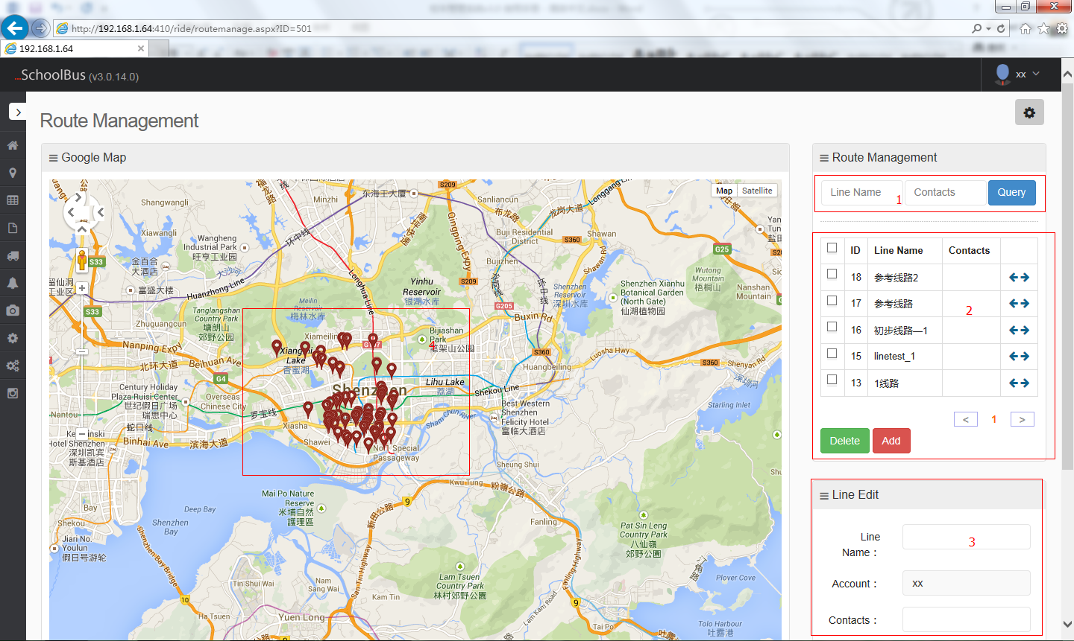

1: Route Search
2:Route List, click go to school or after school routes, respectively, load corresponding setting route.
3: Route Editor
4: Load Settings Site

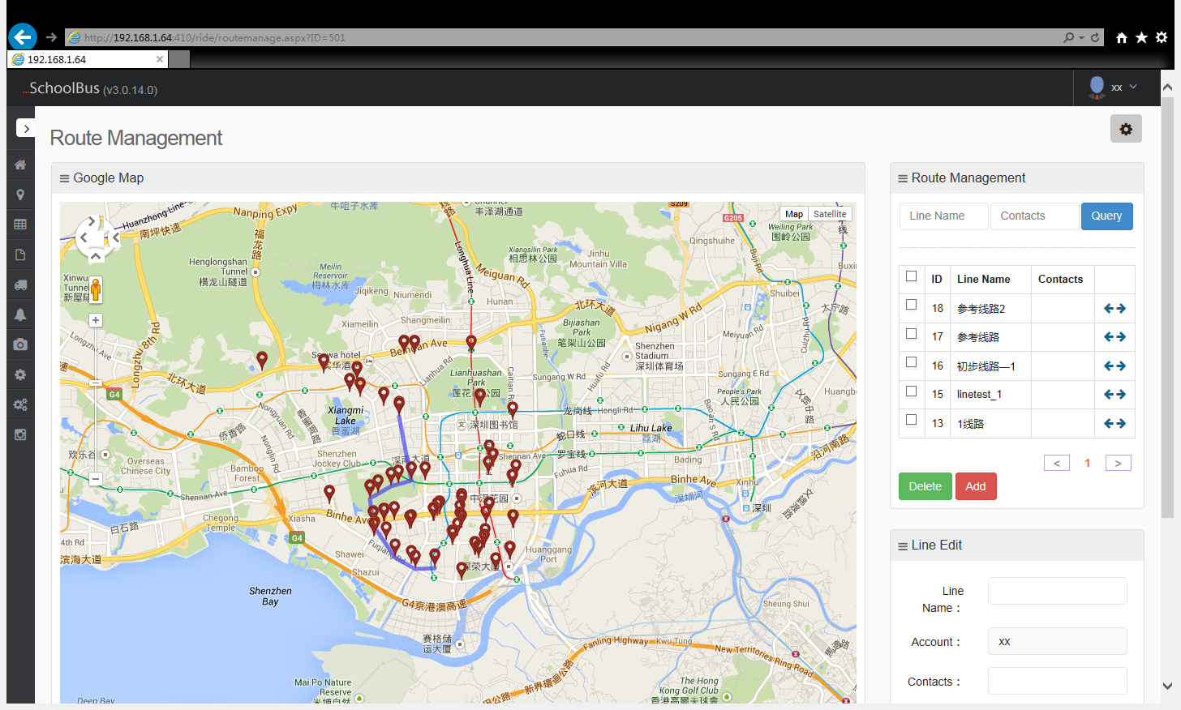

The site connection on the above picture is the setting lines.

8.3 Route Plan

Regard the route as a unit, to plan the vehicle.

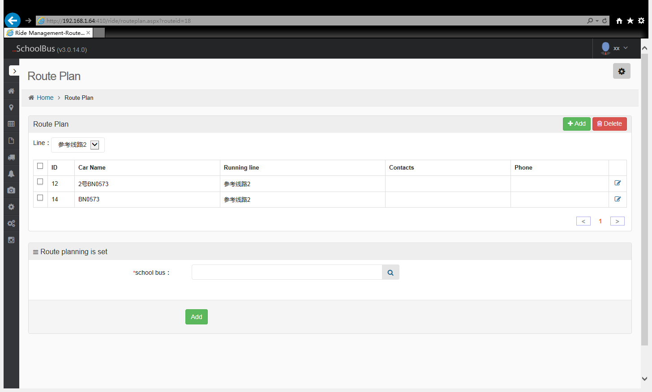

8.4 Geo-fence Setting

Step1 set up Geo-fence on the map
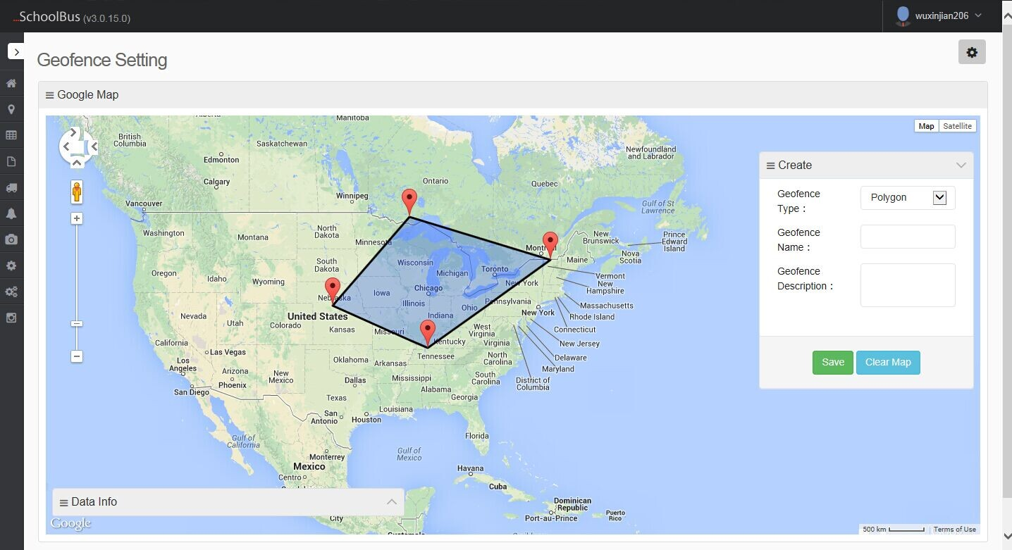

8.5 Test Line Management

Step 1:choose car

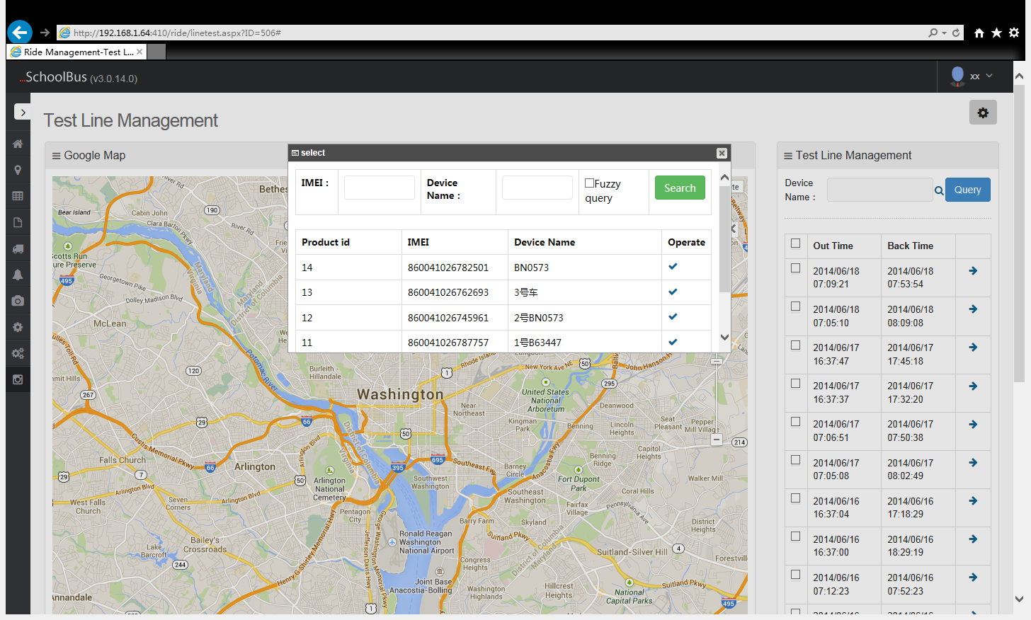

Step 2: Select the test line from the right list. S on the map represents the starting site, P on behalf of the terminal, 1,2,3, N on behalf of the SOS position.

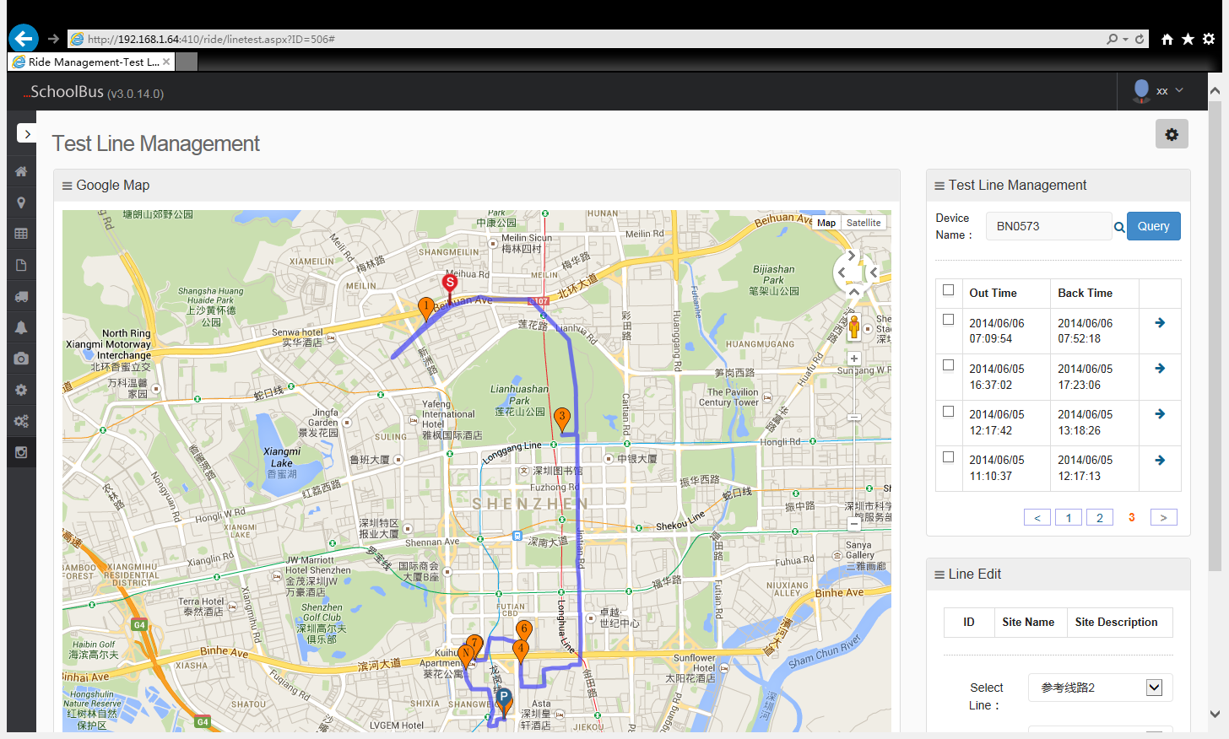

Step 3: Select the site, select the SOS position on the map as the route site
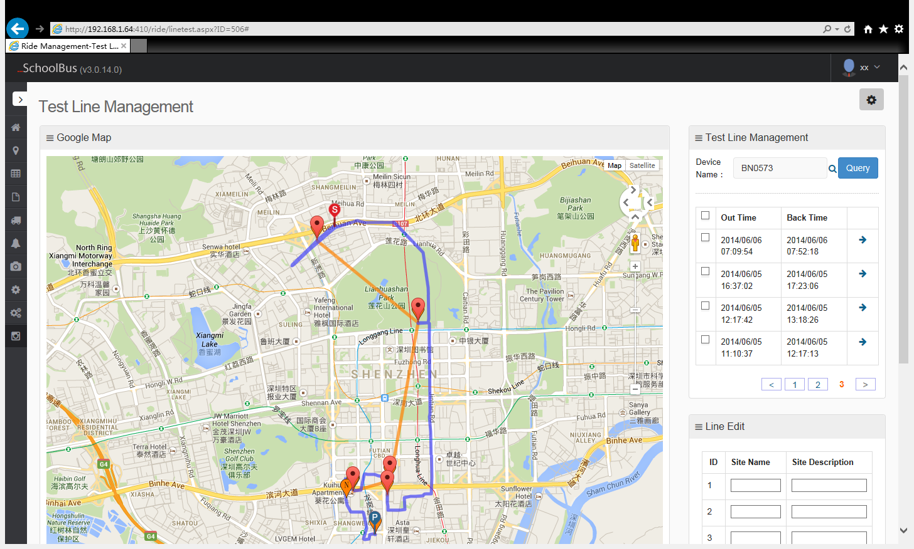

Step 4: Save the routes. Select route, route type and save.

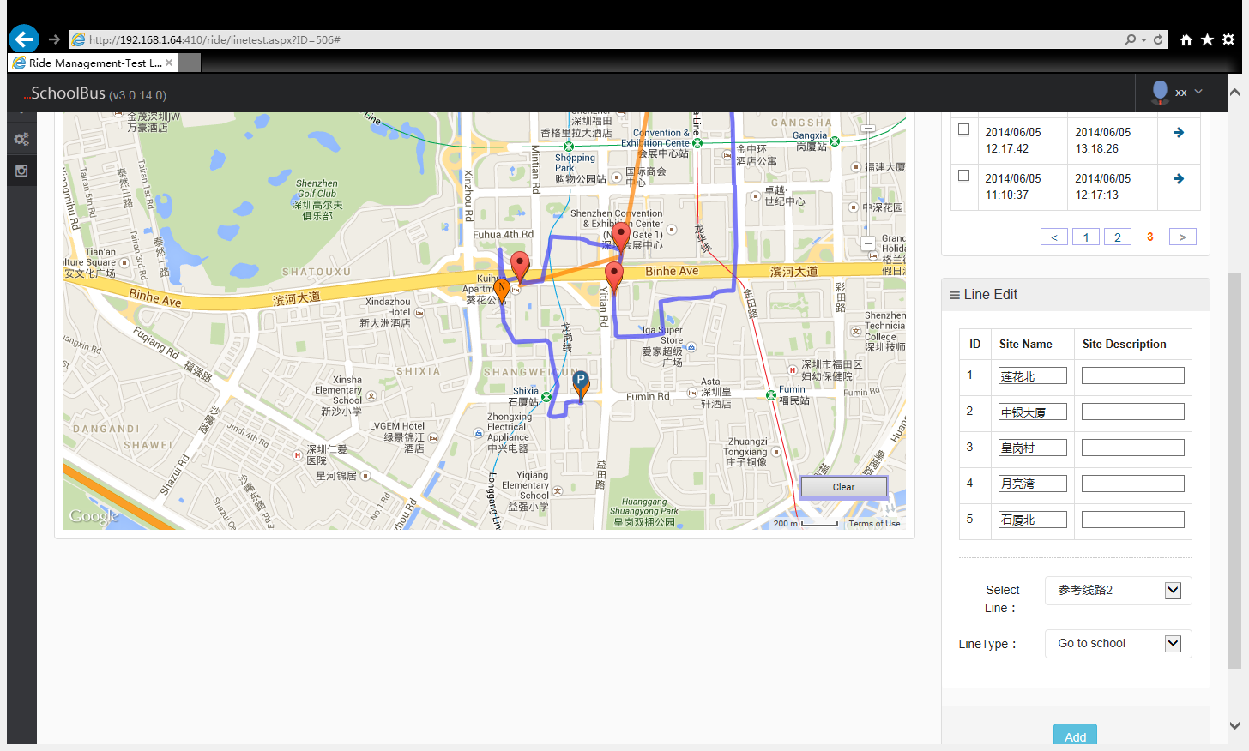

9、Alarm

9.1 Engine Switch

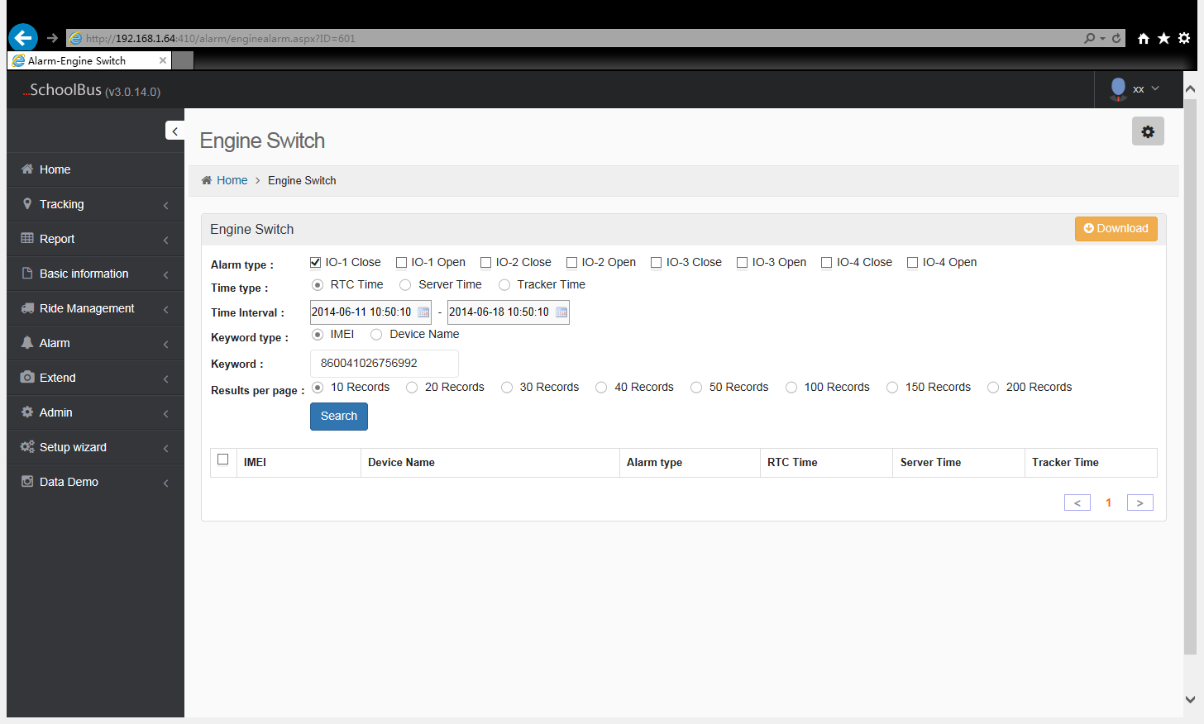

9.2 Geo-fence Alarm

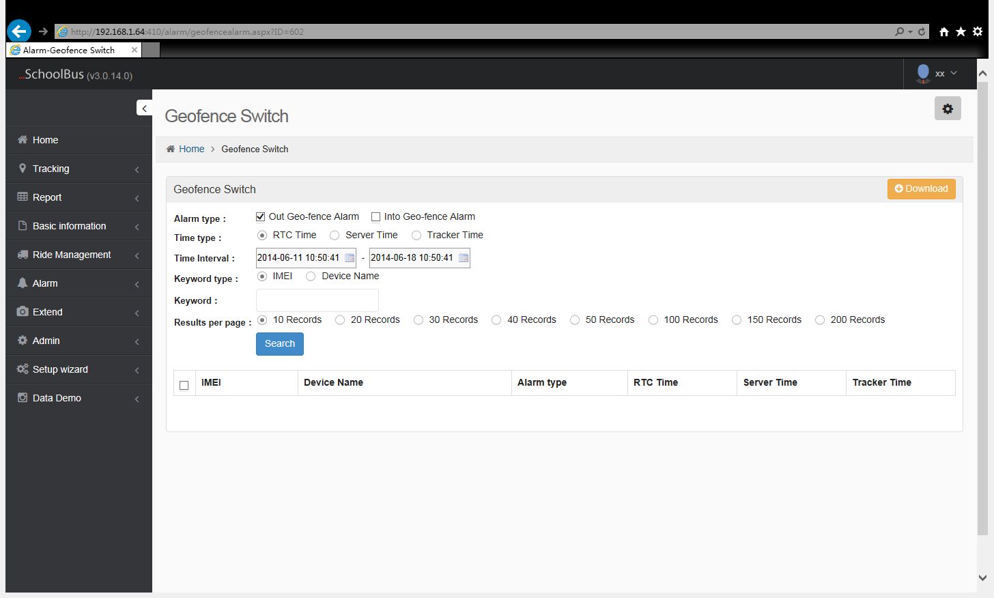

9.3 Sleep Mode

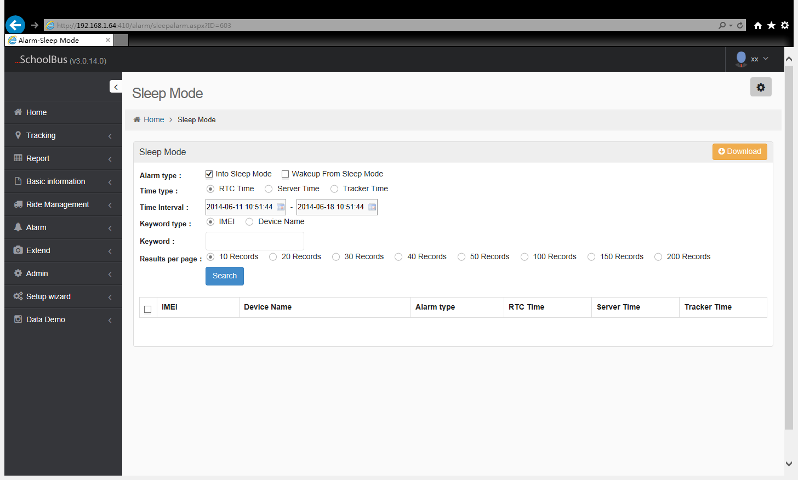

9.4 SOS Alarm

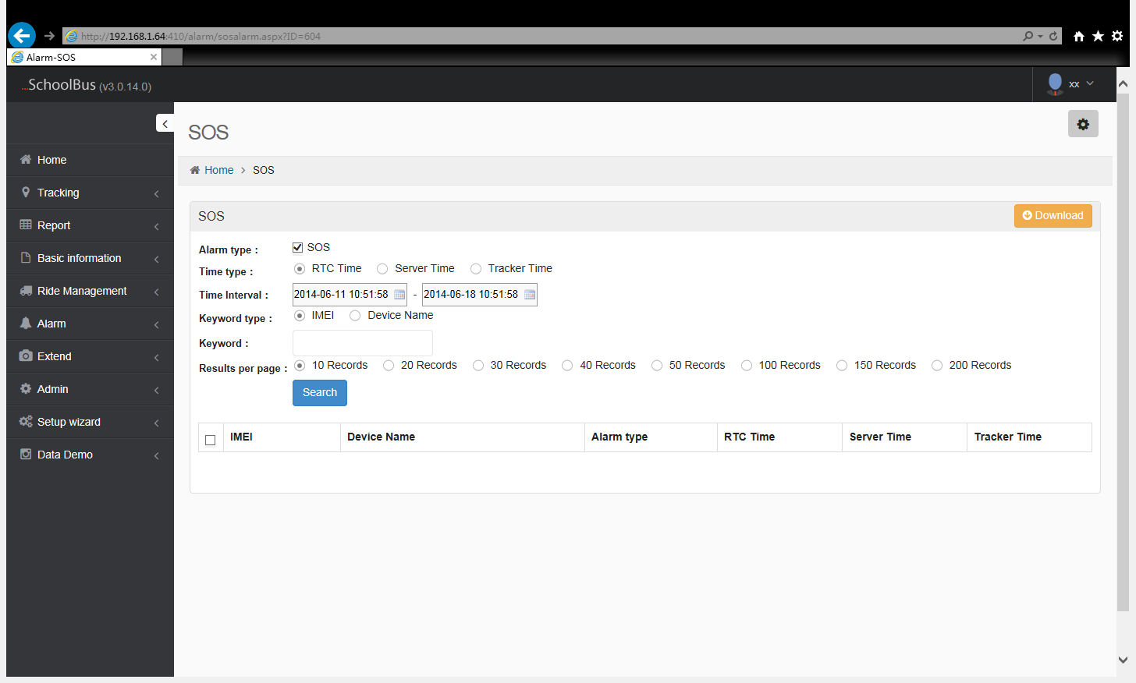

9.5 Voltage State

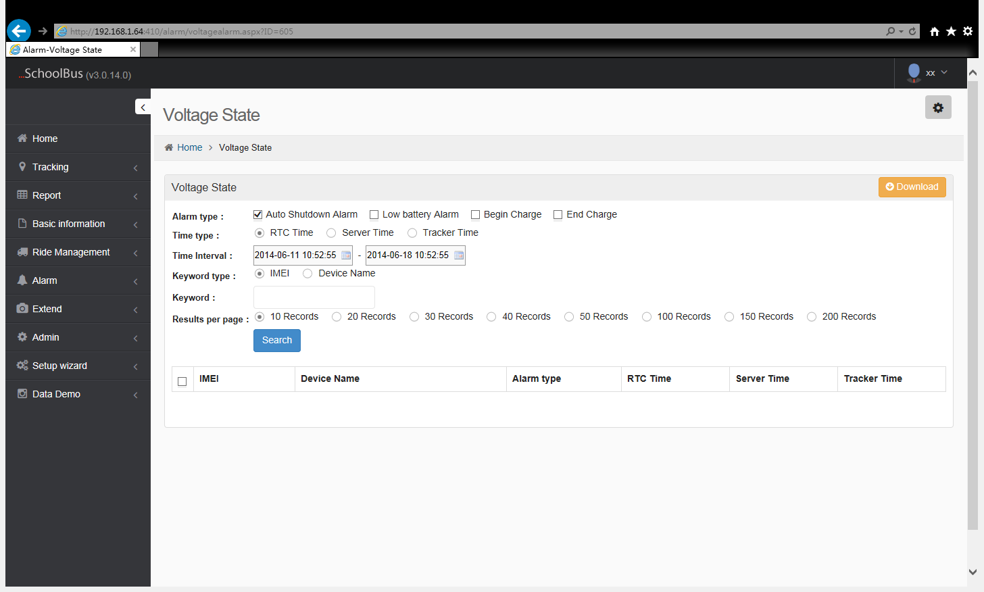

9.6 Tag low voltage alarm

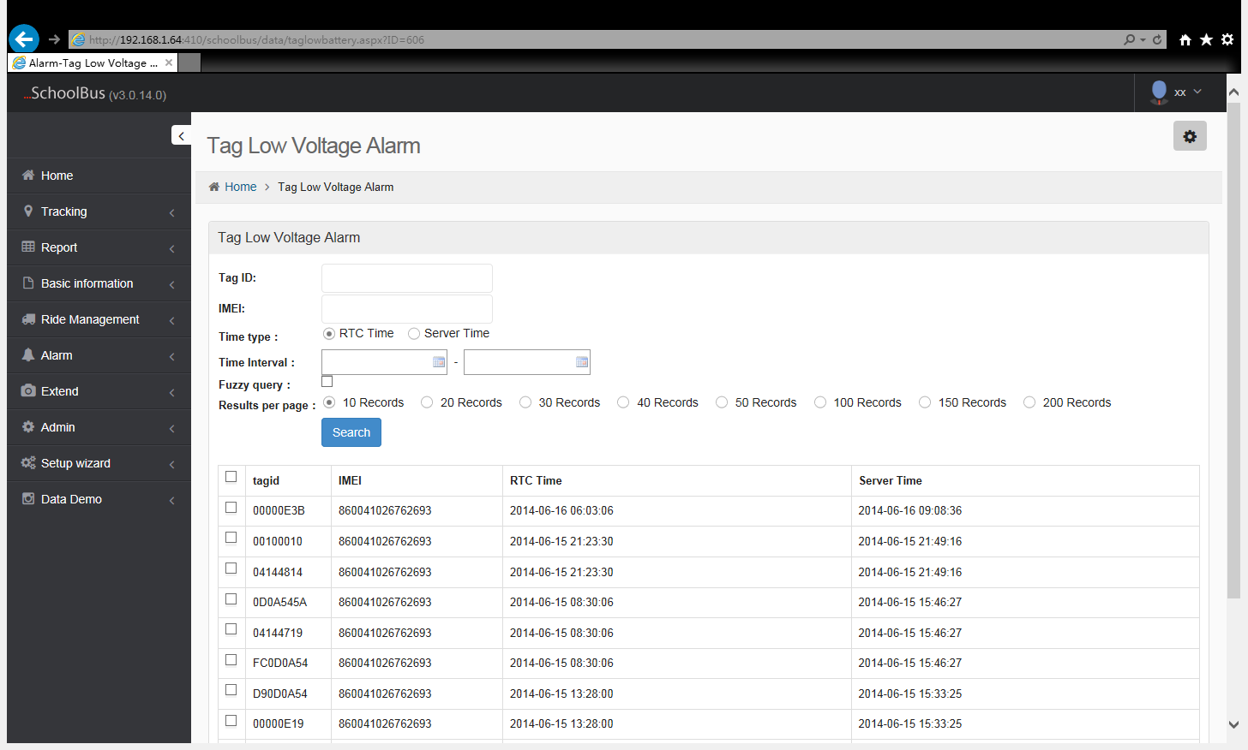

9.7 Route deviation alarm

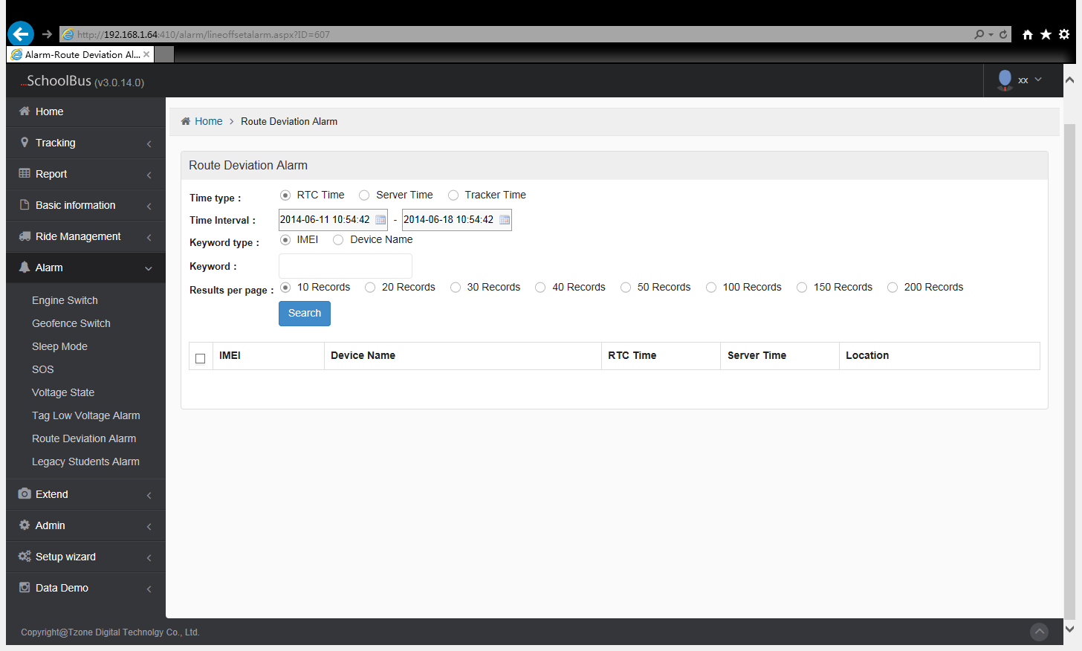

9.8 Legacy students alarm

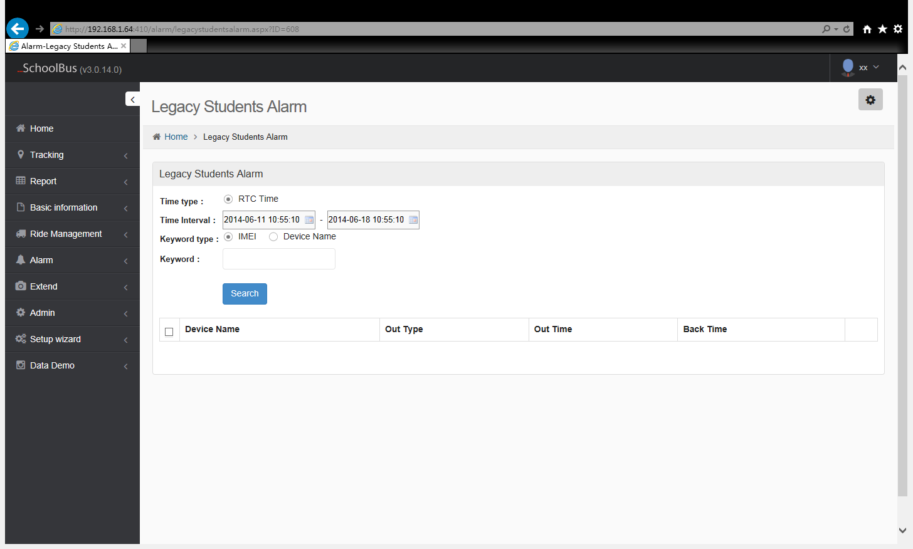

10、Admin

10.1 Account Management

This function helps manager to distribute different roles to different accounts ,it also helps manager to restrict the rights.

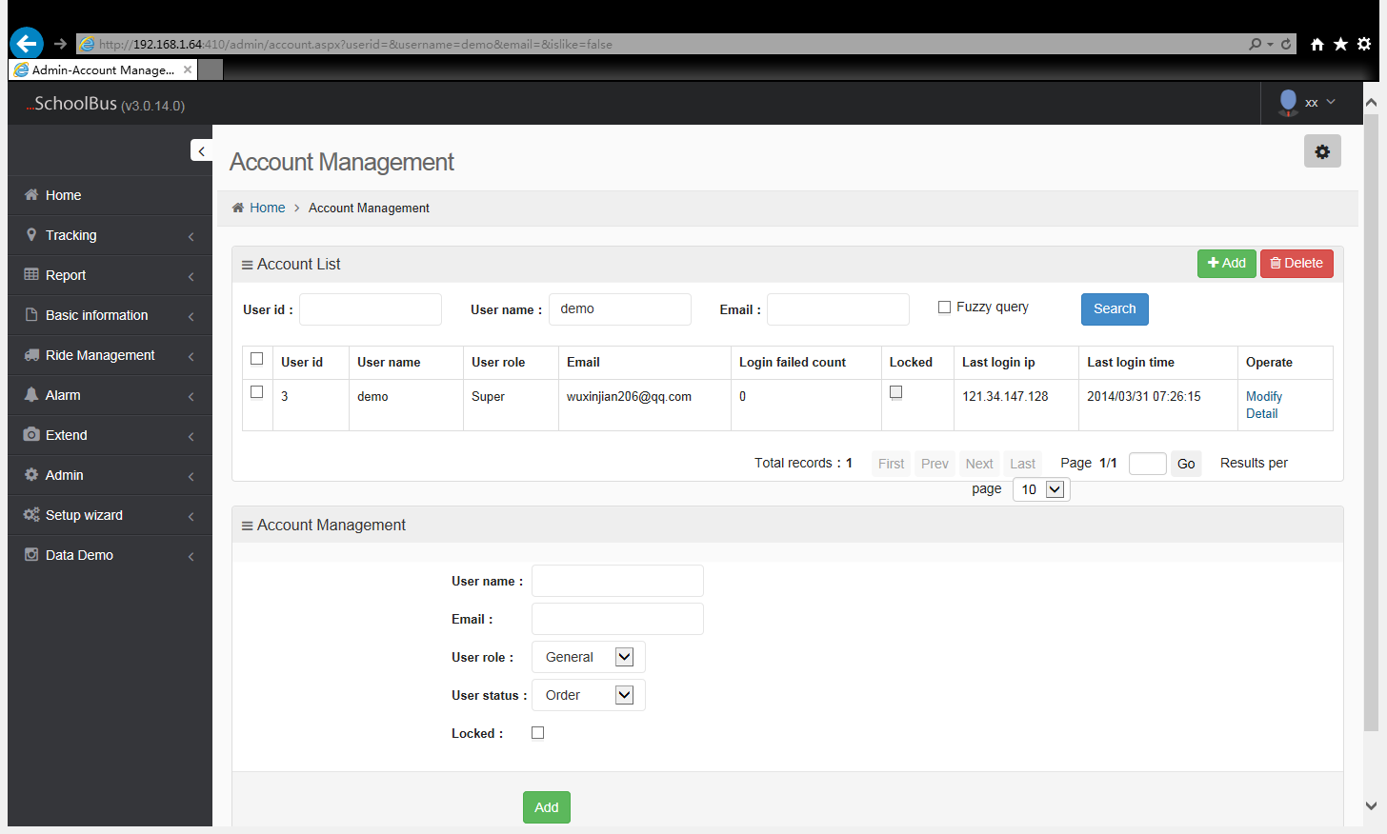

10.2 Product Management

The main function is to activate the machine that the new user add , when activated ,the administrator just need to choose the activated machine and the stop parsing time, click to activate it. Due to the current gateway setting, the machine can work after 1 minutes ,after activate.

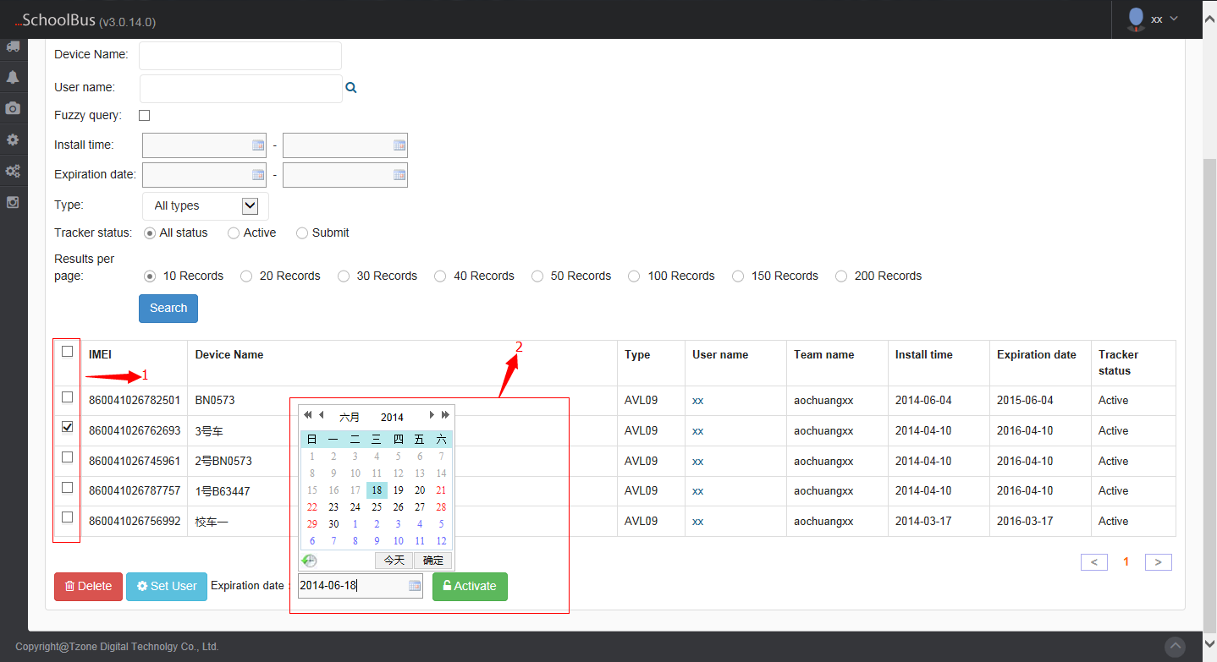

1：Choose the machine that need to activate
2：Set an expiration time, then can activate the machine.

10.3 Data Management

10.3.1 Initial Data
The administrator view the machine upload original data. Mainly used to analysis. The administrator can view all machine datum.

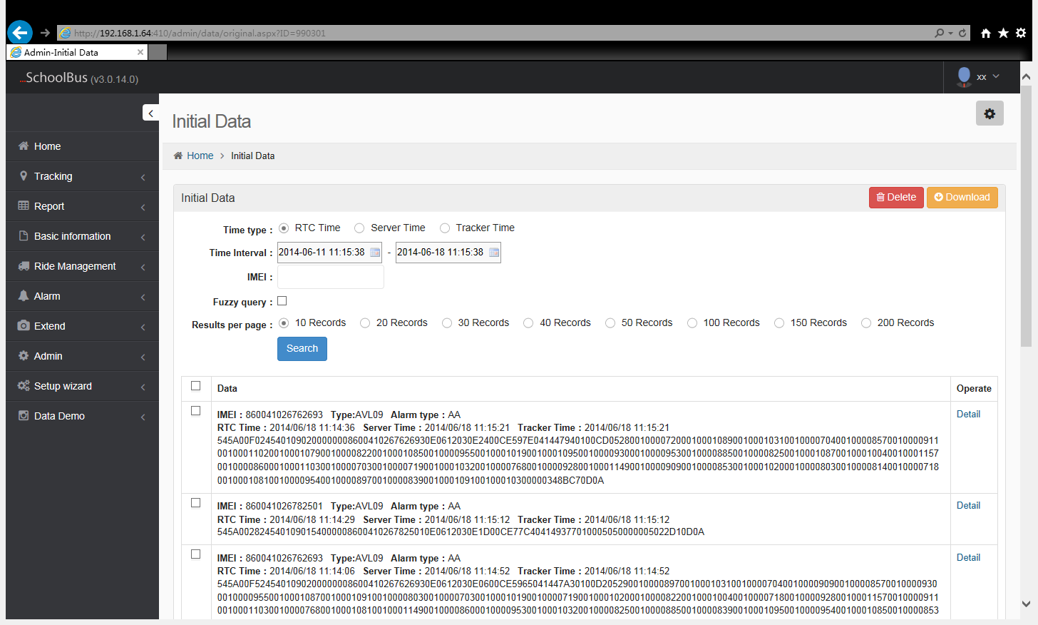

10.3.2 History Data
The administrator can select the time and IMEI number to view all the analysis machine datum.

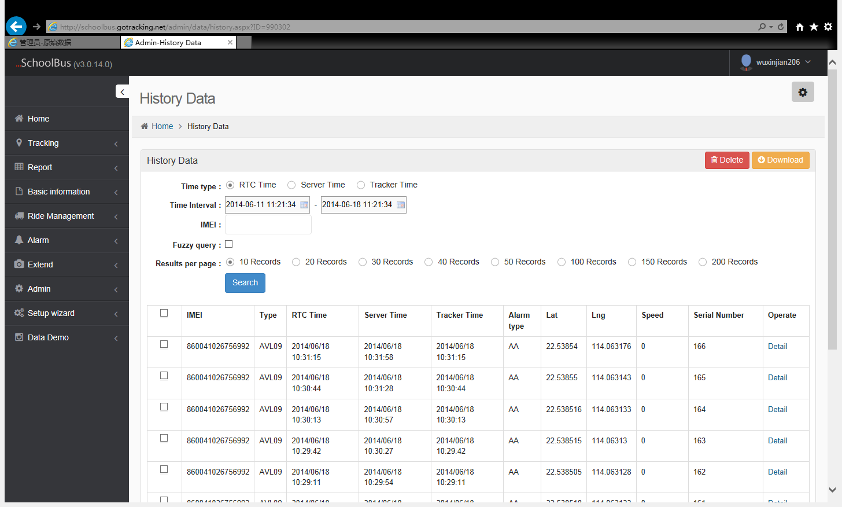

10.3.3 Dynamic data

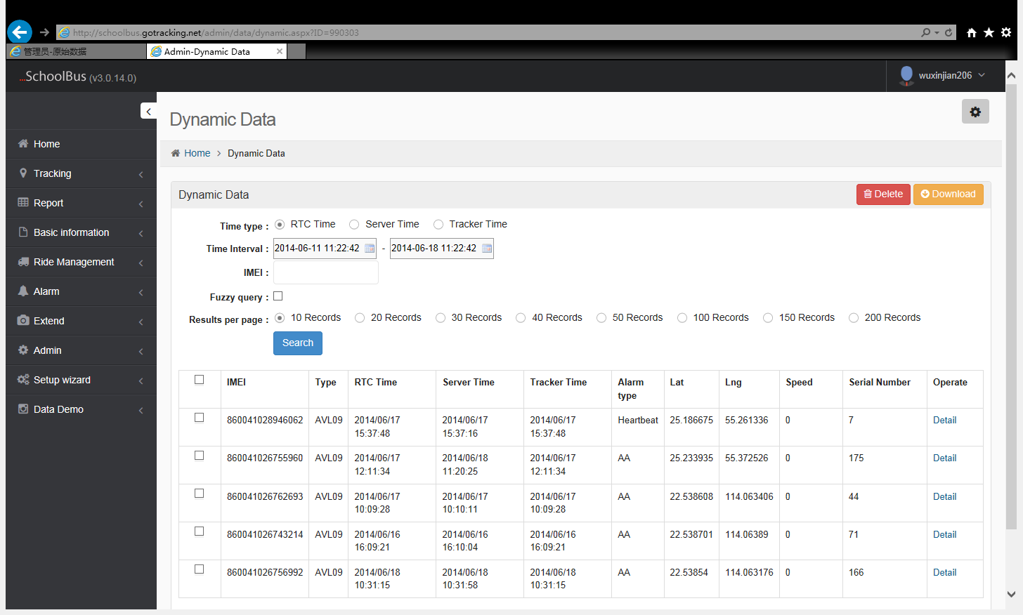

10.3.4 Tag Dynamic Data

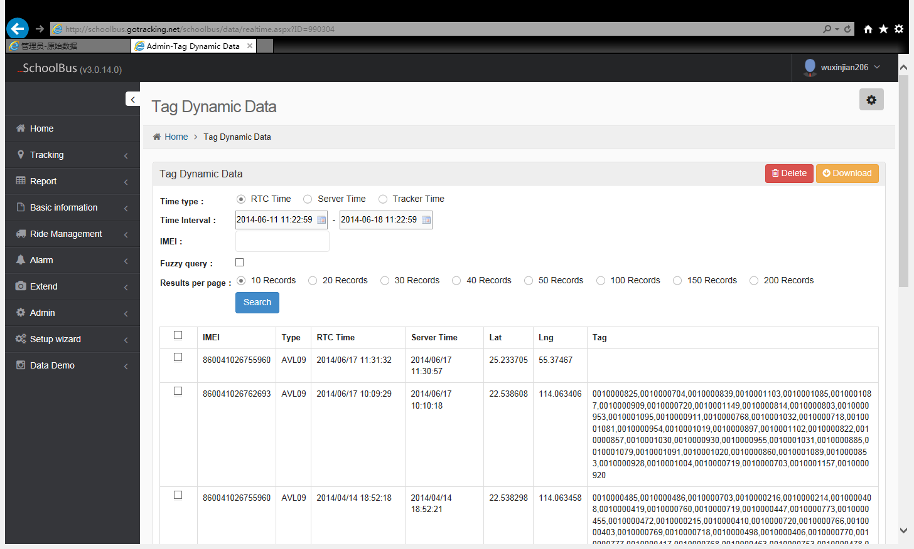

10.3.5 Tag History Data

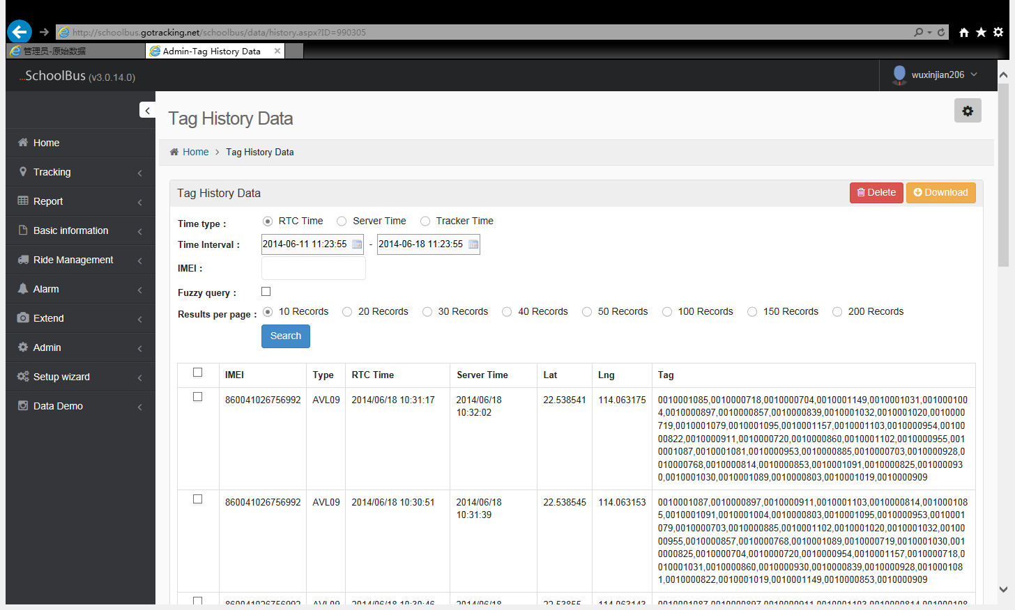

10.3.6 In/out school data

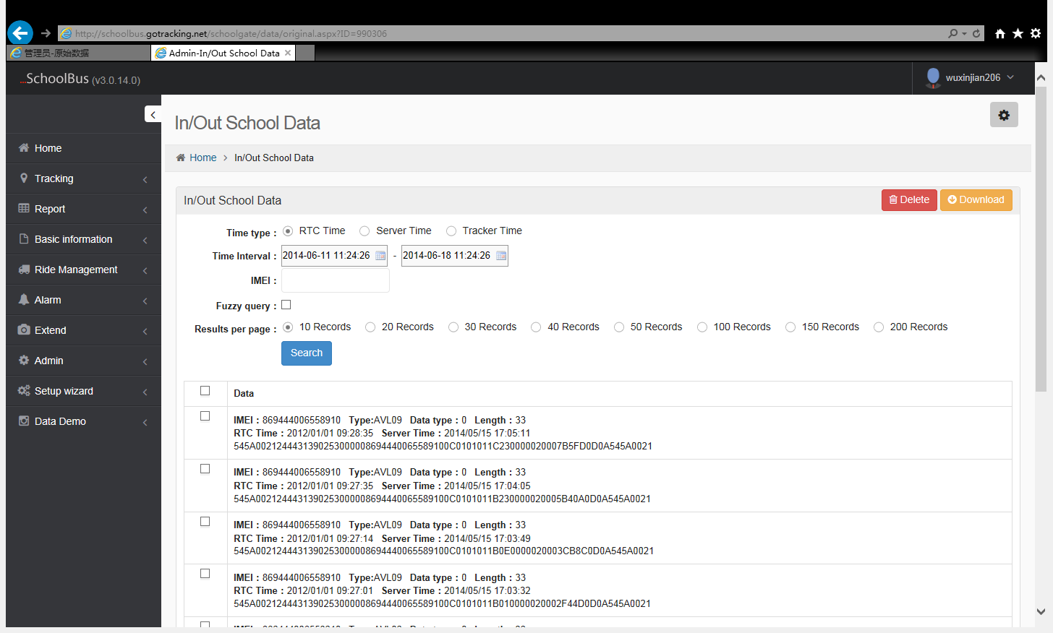

10.3.7 IC history data
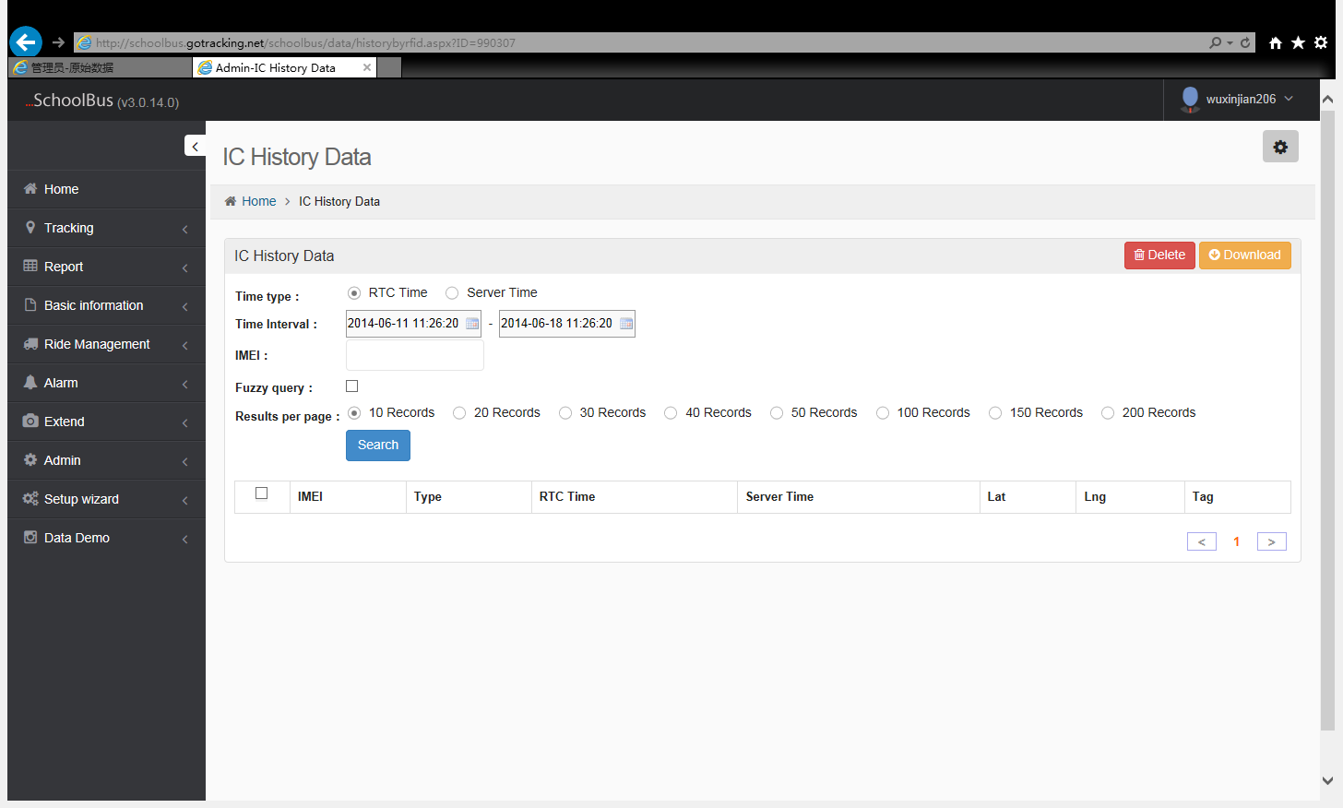

10.4 Role Manage

10.4.1 Role Manage
This function can add different roles for the system, after add the different roles , different user roles have different menu option.Role ID only can less than 99999 ,more than 9999 is the ID of administrator . less than 9999 is a common ID. administrator ID can view all the devices, 99999 is a super user, super user can view all users’ devices. Administrator can not view the super user’s device.

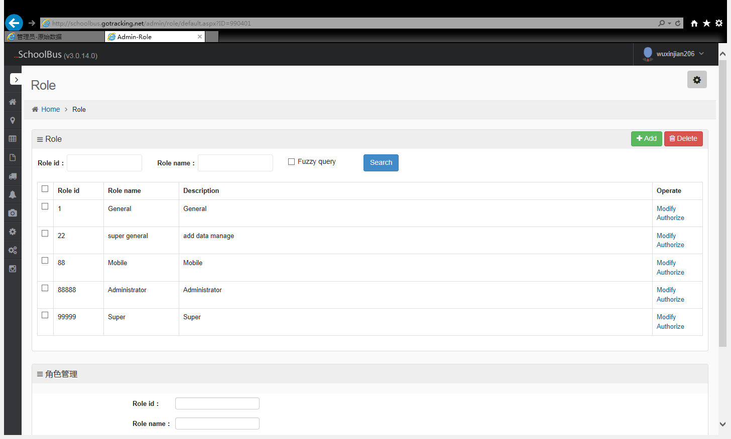

10.4.2 Role authorization
Distribute menu to each role, choose therole , select menus to the role, then click to save.
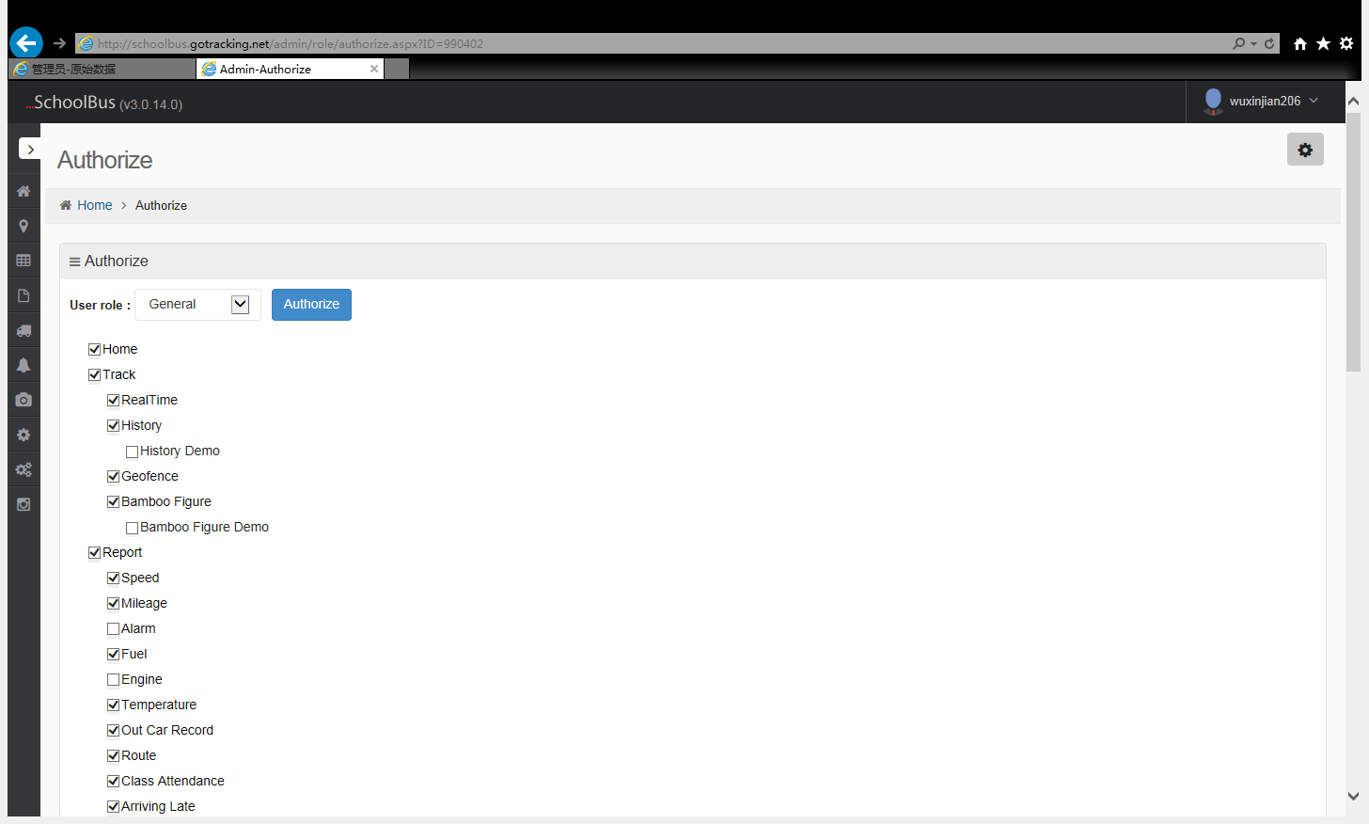

10.4.3 Menu Management
The menus in the list are fixed .In general, not need to modify.

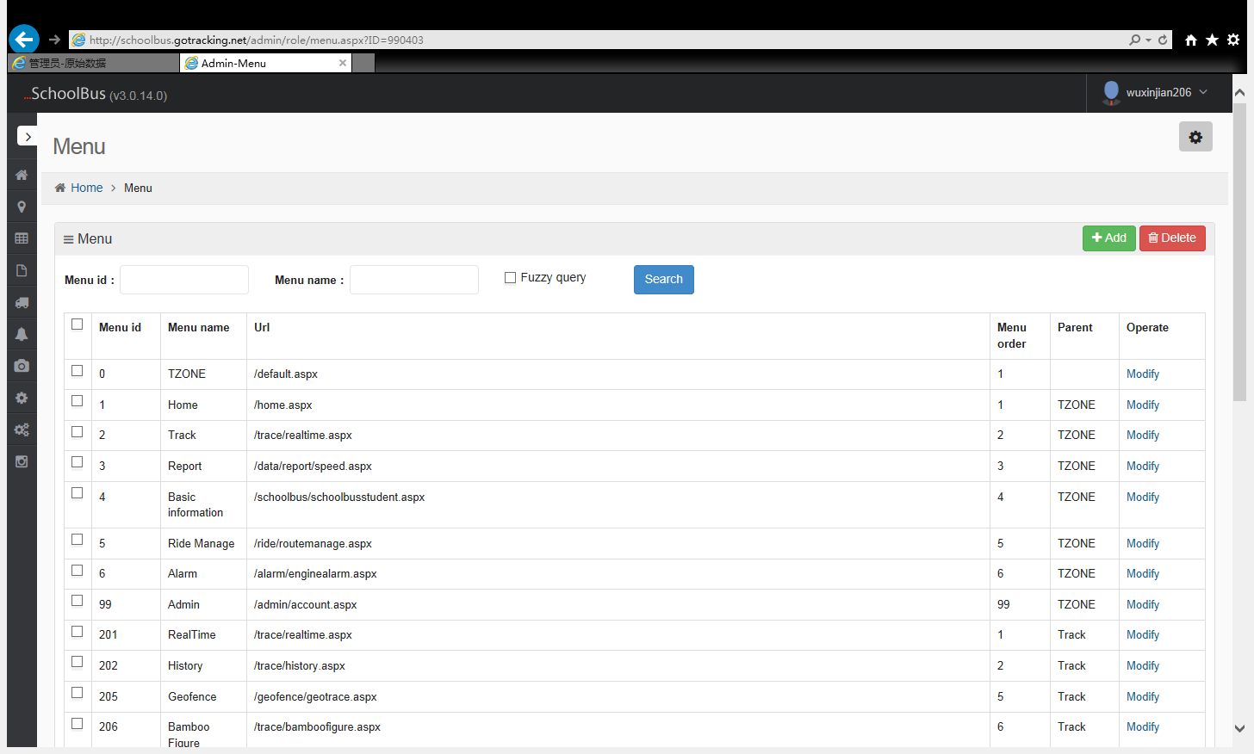

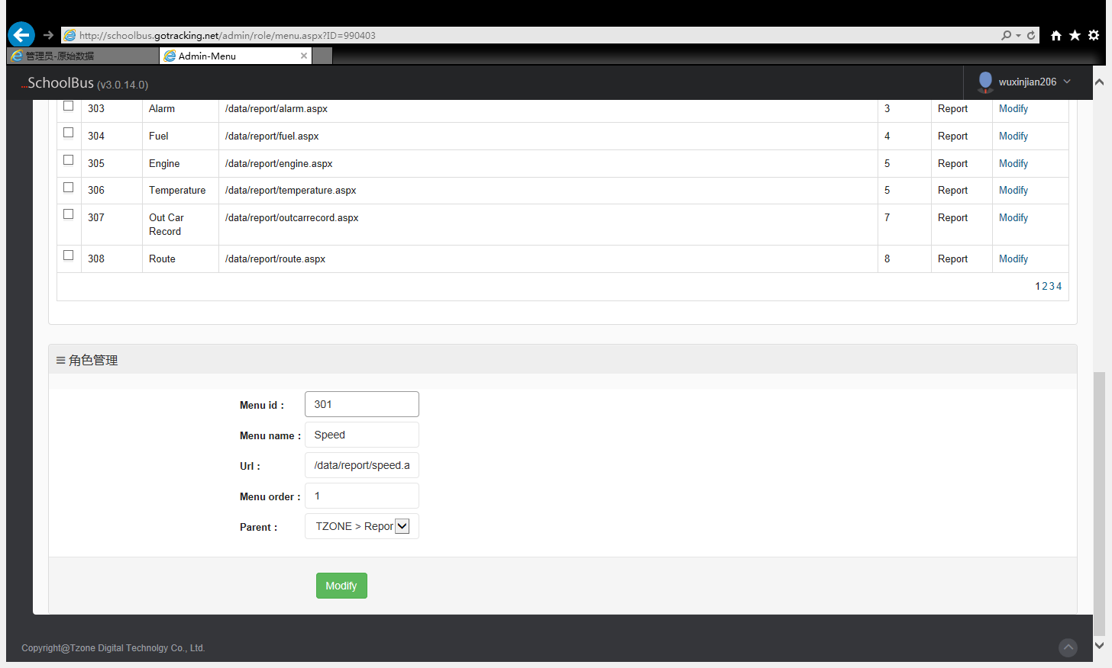

10.5 System Management

10.5.1 Announcement setting
Set the login page to display the system news.

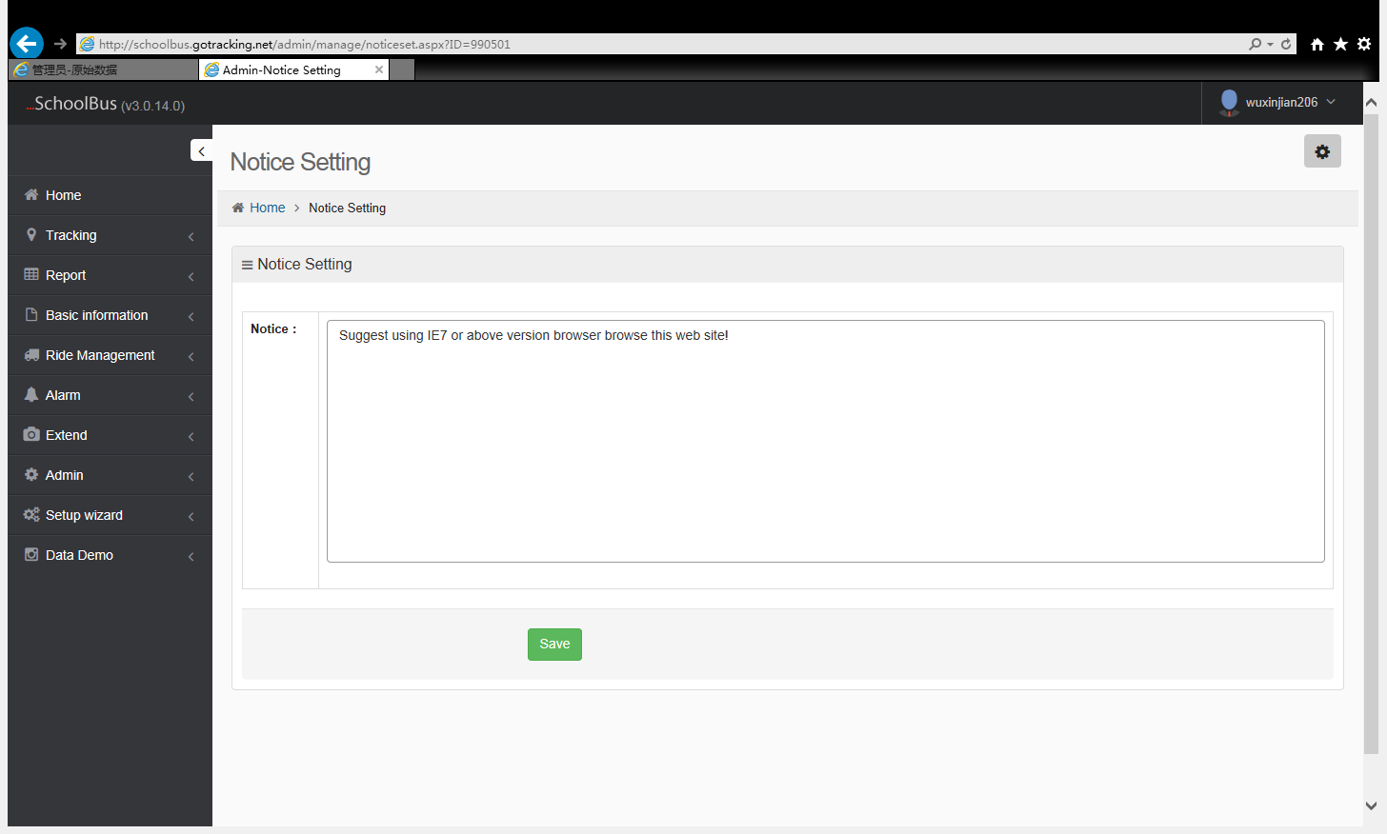

10.5.2 Message push
Administrator push the message to user, user will see the message when login.
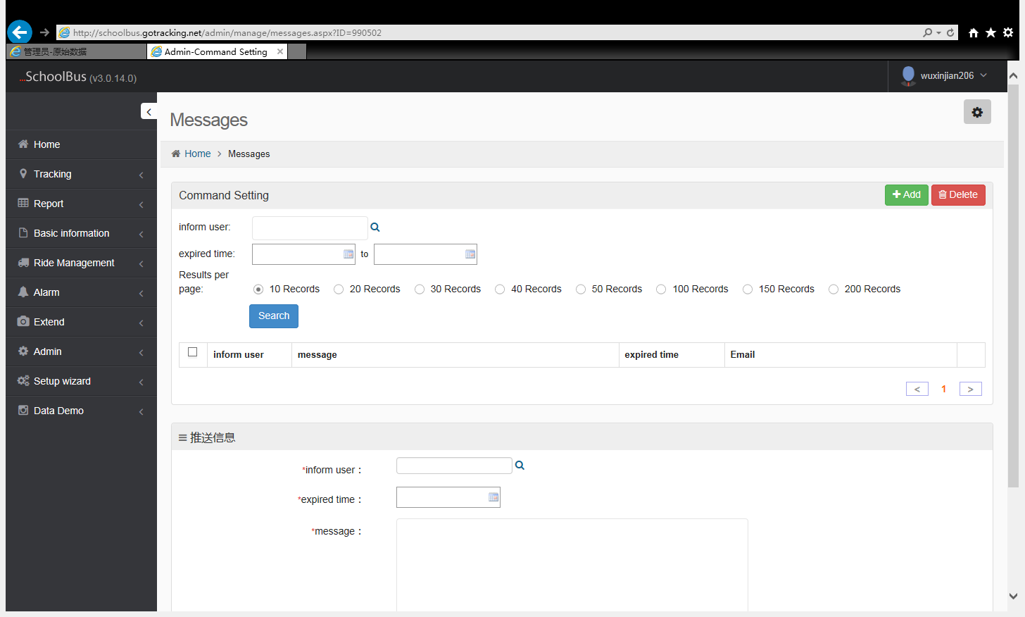

10.5.3 Command Setting
Please use the {N} to represent parameters in the command format,Command parameter description separated by commas.

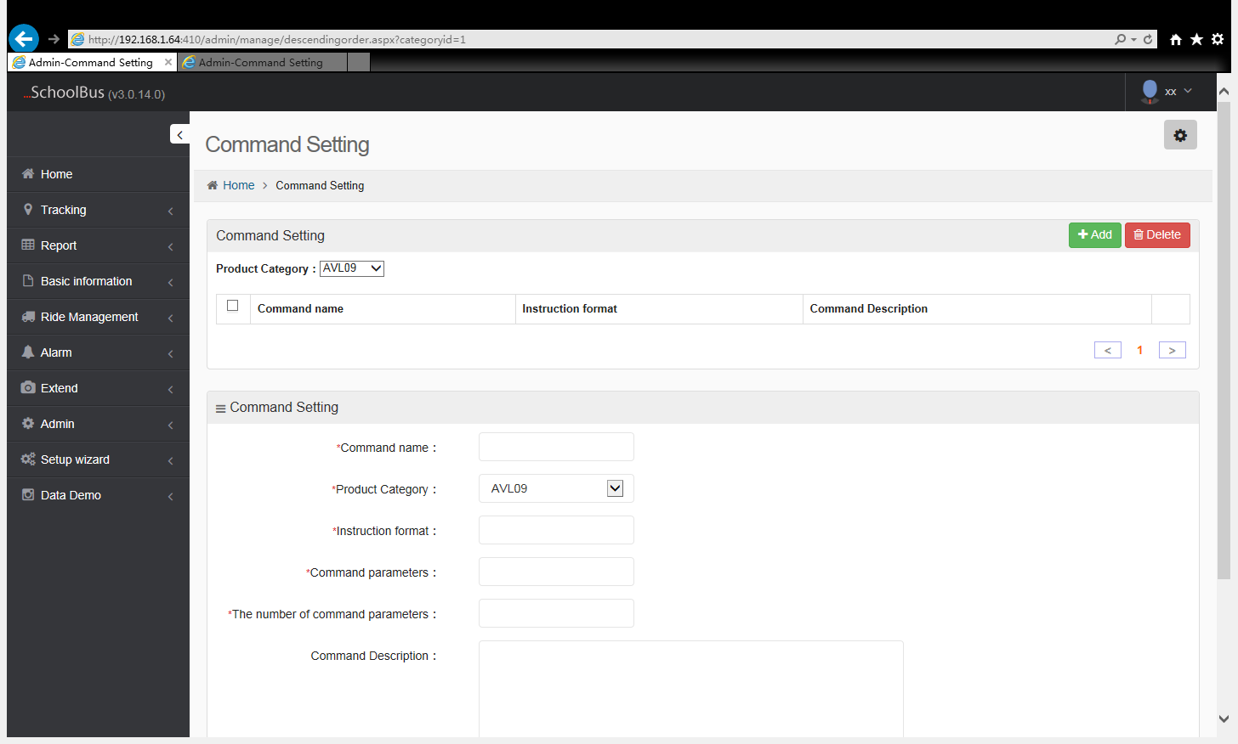

11、Other
11.1 Photo

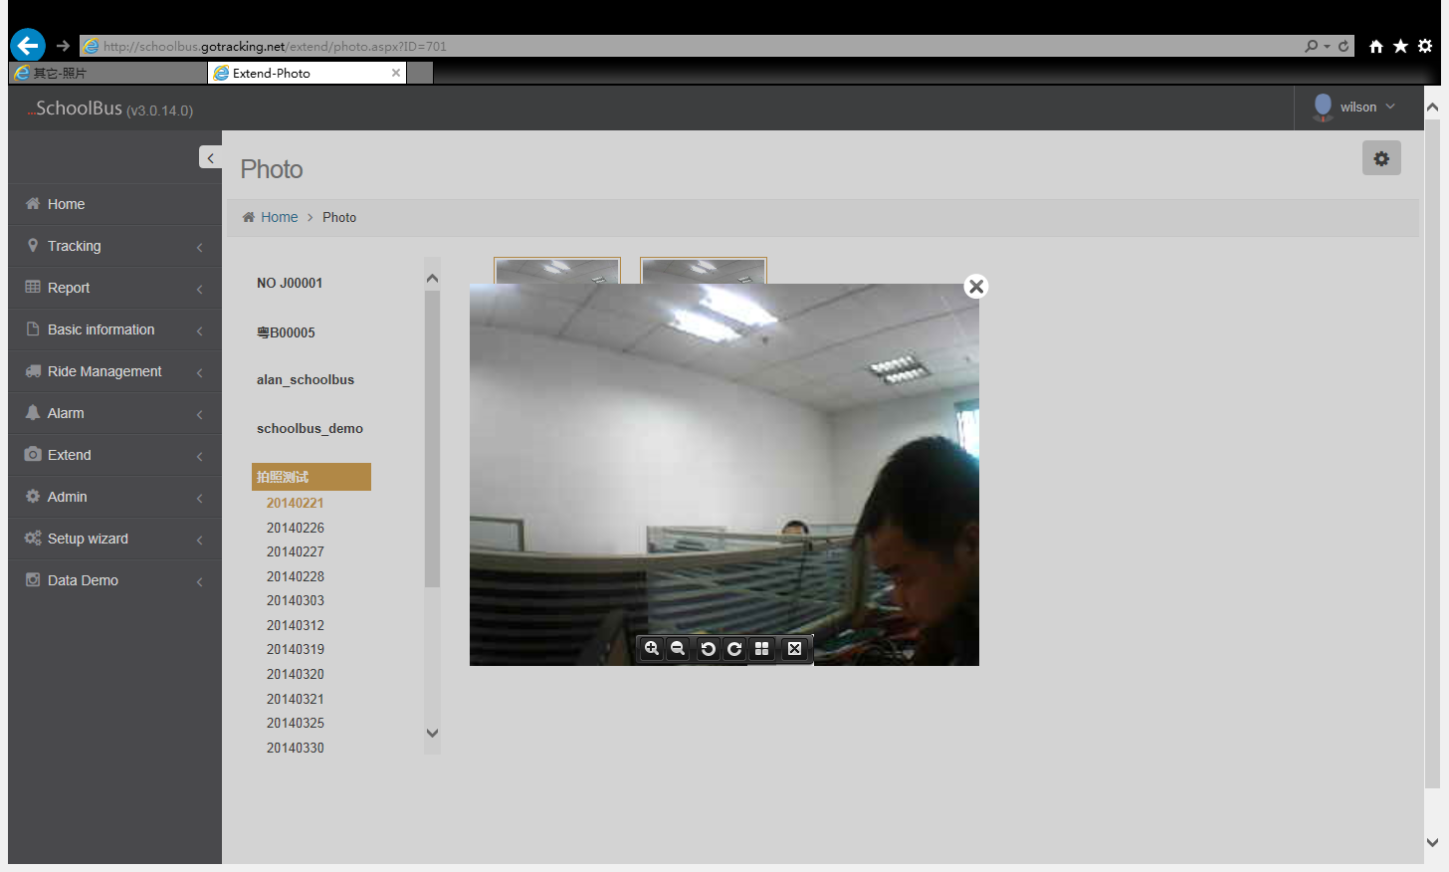

11.2 Down command
1, first find the tracker needed to down command, and then select the down command, then input parameters.

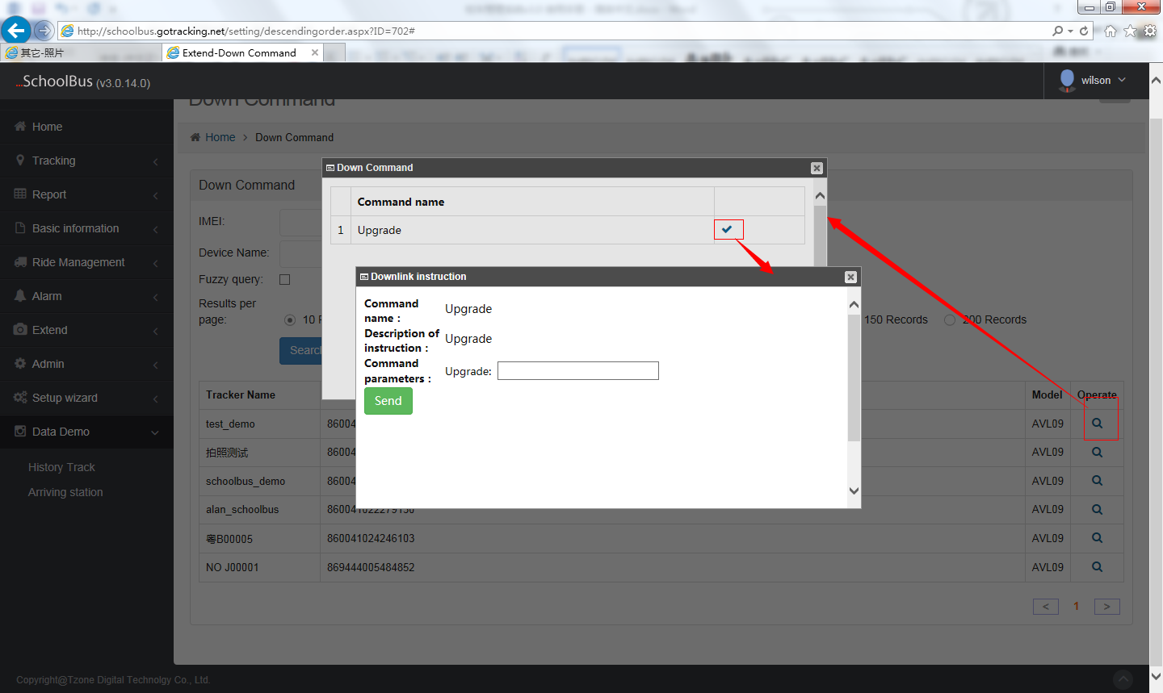

2、Custom down command

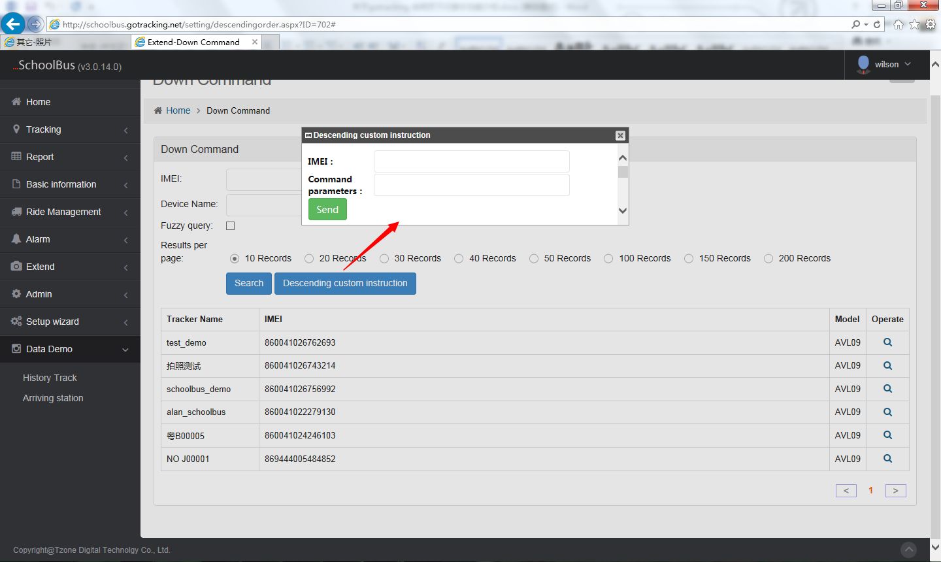

12、Setup Wizard
12.1 Basic Setting

Set up your own account, as well as some parameters must be in system operation

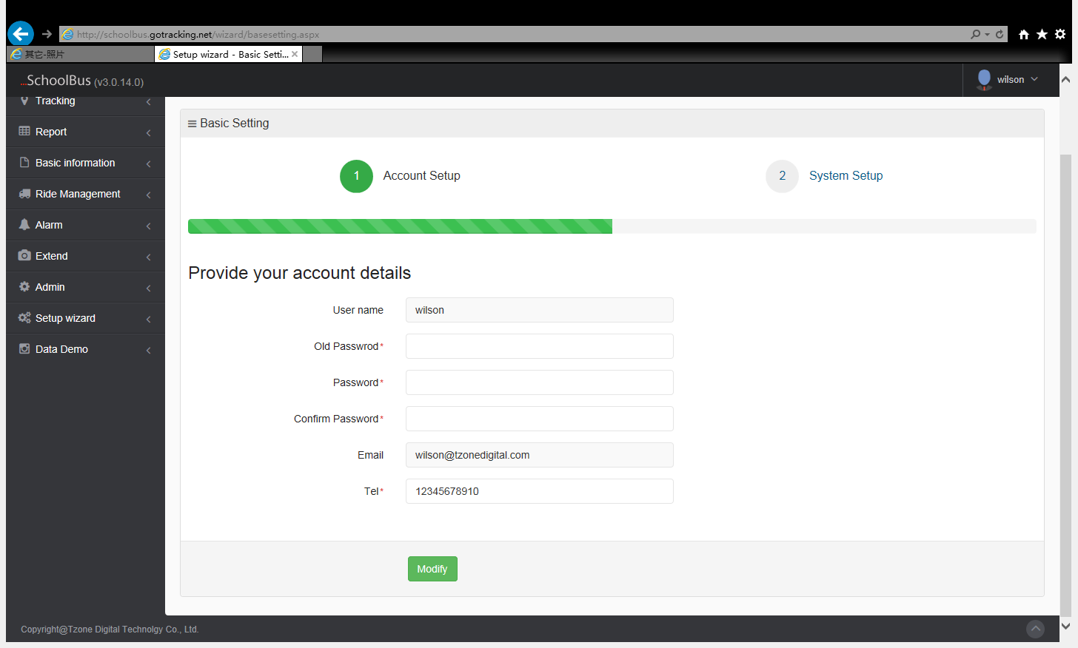

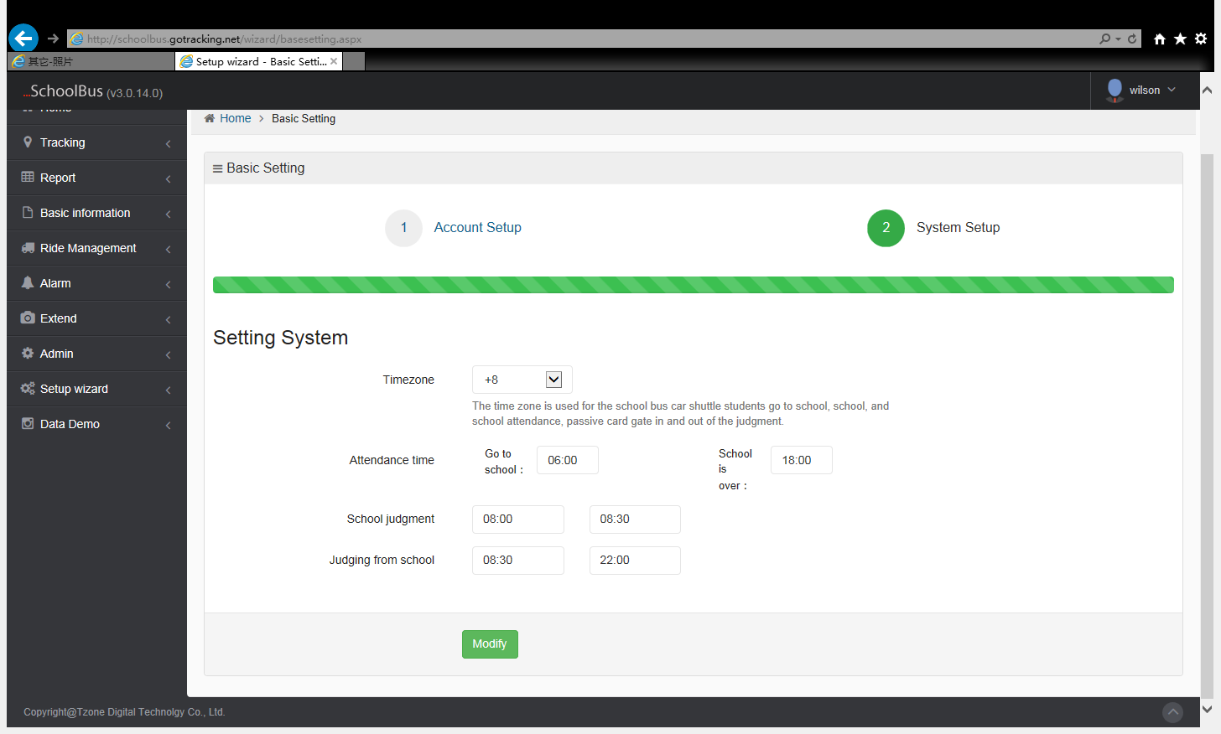

12.2 School bus setting

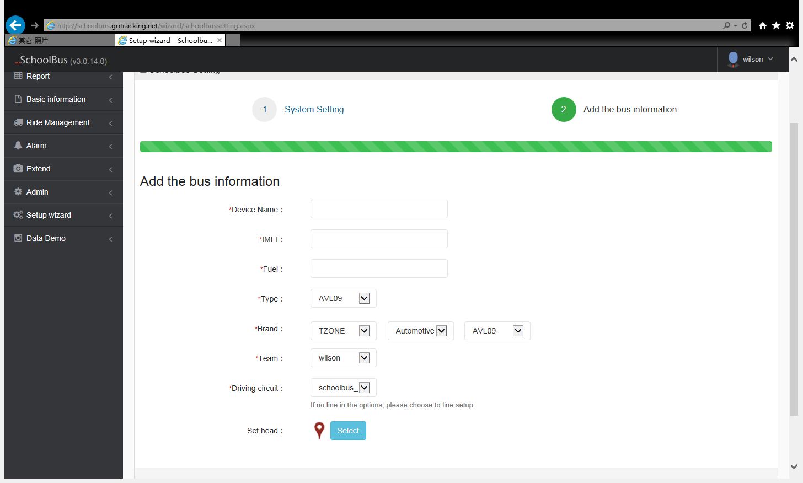

12.3 Route setting (same as the above test line management)

12.4 Personnel setting

Personnel were driver information, teacher information, class information, student information set. Which operate same as the basic information.

